

**The Republic of Uzbekistan**

**The Ministry of Higher and Special**

**Secondary Education**

**Bukhara State University**

**Social-economic faculty**

**Tourism Department**

|  |  |
| --- | --- |
|  | **Permitted to defend**  **Head of Department _______________**  **PhD H.R.KHAMROEV**  **«_____»_______________2015** |

**BACHELOR THESIS**

**Title: Special features of using E-marketing in the field of Hotel industry**

**Mavzu: Mehmonxona biznesida elektron marketingning imkoniyatlaridan foydalanishning o’ziga xos xususiyatlari.**

**Author: 5610200-"Forming and managing hotel industry"**

**3-1MX-11 group graduate student Djuraev Murod**

**Supervisor: Teacher Khurramov O.K.**

**The date of defense The mark of S.A.C**

**«____»___________2015 ___________________**

**The conclusion of S.A.C**

**Bukhara – 2015.**

**The Republic of Uzbekistan**

**Ministry of Higher and Special Secondary Education**

**Bukhara State University**

**Social-economic faculty**

**Economic Education and Tourism Department**

**Speciality: 5610200-"Forming and managing hotel industry"**

**“Confirmed”**

**Head of Department_____________**

**«____»____________2014**

**Djuraev Murod Barotovich**

***TASK***

**The title of bachelor thesis: “Special features of using E-marketing in the field of Hotel industry”**

**Mavzu: Mehmonxona biznesida elektron marketingning imkoniyatlaridan foydalanishning o’ziga xos xususiyatlari.**

**1.Confirmed with the order of university ______________________**

**2.Completion date of bachelor thesis by author______________**

**3.The content of explanation letter__________________________**

**The list of questions related to the bachelor thesis:**

**4 The quantity of charts ( Important drafts with indicators)**

**5.Scientific advisors:**

**6.Supervisor teacher Khurramov O.K.**

**7.Date of the completion of task_________________________________________**

**8.Task is approved for performance______________________________________**

**Student’s signature________________________**

**The head of department’s signature________________**

Note: This task is appendix for comleted thesis

**TABLE OF CONTENT**

Introduction................................................................................................................ 4

**Chapter I. The major role of using E-marketing with special features and its essence.**

1.1. History and definition of e-marketing...................................................................7

1.2. The impact of electronic commerce on the efficiency of the economy around the world............................................................................................................................17

1.3. The real advantages and disadvantages of E-marketing.......................................22

**Chapter II. The contribution of E-marketing in the field of hotel industry**.

2.1. A successful E-marketing strategies and its main roles in hotel industry............27

2.2. Online marketing in tourism destination..............................................................31

2.3. The social impact of e-marketing for hotel sphere..............................................33

**Chapter III. The development of online marketing and its essence in Uzbekistan.**

3.1. Online marketing activities for contemporary tourism and travel companies in Uzbekistan ..................................................................................................................35

3.2. Analyzing official web site of Uzbekistan as a case company............................39

3.3. Making SWOT analyzing of Uzbekistan's web site............................................52

CONCLUSION AND RECOMMENDATIONS………………………............... 56

ANNOTATION…………...……………………………………………………… 60

REFERENCES…………………..…………………………………………………73

**Introduction**

*“e- Marketing is the wave of the future. Fast and cost-effective, e-marketing must become an important part of your integrated marketing and media plan.”*

Peppers & Rogers Group

Commercial relationship between subjects of production and consumption

is established by specific communication technology. From oral transmission,

Through fairs, printing press, telephone to television and electronics, i.e. information technology, technology of the communication market has been changing, and consequently the market relations character has changed. Electronic technology has allowed for the first time in history for market participants to simultaneously communicate at a distance, which introduced new era in the field of marketing communications. The network of communication

Satellites has enabled the fastest information transfer among all parts of the world, i.e. E-marketing.

E-marketing , as a set of networks around the world, represent the biggest computer system which allows receiving, process and exchange of information to millions of computer users. A huge amount of data can be accessed at any time and any place allowing the user of E-marketing a global access. The Internet technology provides a new way of conducting business in all electronic sectors. The E-marketing has become an important source of information according to which various business strategies of subjects in tourism industry are formed. With the help of E-marketing , a new possibility appeared for subjects in tourism industry to successfully promote and sell services and products to comply with demands, needs and desires of consumers.

Today, there is no doubt that the Electronic Marketing has contributed positively in the field of modern societies, mainly consuming societies. It allows purchasing of materials cheaply without any limits and without any restrictions. It also gives chances to make a free selection and comparison between the prices of goods at the electronic department stores throughout the Internet. All such facilities are given to the consumers in any short time without causing them to leave their office and home. In addition, the Electronic Marketing has exterminated the monopoly of the goods and materials, all such acts of course are for the consumer’s.

However, in addition to such advantages there are a few disadvantages of such type of marketing the Electronic Marketing has deleted the privacy of consumers , because of all his movements through the Internet has been divulgated and under control, in addition to lack of exclusive security through the Internet. Accordingly, many losses equally occurred to the costumer and the merchant due to such acts of hackers who reveal the information and credit cards details.

Last but not least, the Electronic Marketing is able to cause upset down in many concepts and standards of economic science that have existed for so many years. Doors are still open for every new in this assumption and endless world as there no limits than can stop such human ambition.

**Urgent topic of the research.** The increasing competitiveness in the Uzbekistan tourism market encourages tourism operators to investment more in promotion, resources, knowledge and quality in order to achieve satisfactory growth. Therefore, it is extremely important to be in touch with the latest technological trends including and have the knowledge required to effectively respond to the challenges of global competition as choices for e-marketing via computers and mobile phones at a faster and easier way can reach to tourists.

**Research approach of problem context** This paper defines the role of online marketing as new strategies for promoting tourism products and services; it examines their advantages and disadvantages, the impact of online and mobile marketing on the tourism supply and demand, as well as the estimated future development of this channel.

Furthermore, the paper analyzes social media marketing as well as mobile marketing as a new tool to promoting and advertising tourism and hotel products and services.

**Object and Subject of the research.** The subject of the thesis is developing online marketing especially via computer devices and smart phones which offer new advertising forms as well as the methods and strategies of promoting tourism business fruitfully.

**The object of the research** is analyzing special features of using e-marketing in the field of hotel industry and giving recommendations and investigating official tourism portal of Uzbekistan as a case company

**The purpose and missions of the research** The purpose of choosing this research is developing how tourism industry can use e-marketing as a promotional tool as well as increasing the number of tourists in Uzbekistan by effective online marketing so as to reach their destinations easily via computer and mobile devices.

Missions along with thesis:

* Understanding the meaning of online marketing both theoretically and practically
* Comprehending to promote tourism business by using methods of e-marketing in the internet namely, official tourism portal of Uzbekistan
* Building Customer Relationship as long as tourism companies can interact with customers to learn more about their needs by online marketing.

This thesis consists of introduction, 3 chapters and conclusion, annotation, references as well as appendix.

**The introduction** informs about the urgency of the topic, research approach of problem context, object and subject , the purpose and missions of the research.

**The first part** is dedicated history and definition of online marketing, delivering methods and benefits of online marketing in travel companies and online marketing activities for contemporary tourism and travel companies

**The second part** is named as the contribution of E-marketing in the field of hotel industry and it clarifies mobile marketing overview and types of e-marketing advertisements, mobile advertising via social media marketing and the role of mobile marketing in the promotion of tourism.

Finally, **the third part** is more practical which is analyzed official web site of Uzbekistan as a case company and discovered some disadvantages of the site and giving the precious advices.

In **conclusion** part, the chances and prosperity of online marketing are defined with giving some useful recommendations.

**Chapter I. The major role of using E-marketing with special features and its essence.**

**1.1. History and definition of e-marketing**

E-marketing is also known as Internet marketing, web marketing, e-commerce, online marketing or digital marketing. It is growing at a dramatic pace in the hospitality industry and is significantly impacting the business behaviors since it drives more revenue than traditional marketing. A successful e-marketing strategy should comprise a set of specific e-actions that help hoteliers reach their planned objectives.

**Search Engine Marketing (SEM)**

Search Engine Marketing is designed to increase a website's visibility in [search engine results pages](http://en.wikipedia.org/wiki/Search_engine_results_pages) (SERPs). Search engines provide sponsored results and organic (non-sponsored) results based on a web searcher's query. Search engines often employ visual cues to differentiate sponsored results from organic results. Search engine marketing includes all of an advertiser's actions to make a website's listing more prominent for topical keywords.

**Image 1. Search Engine Marketing (SEM)**

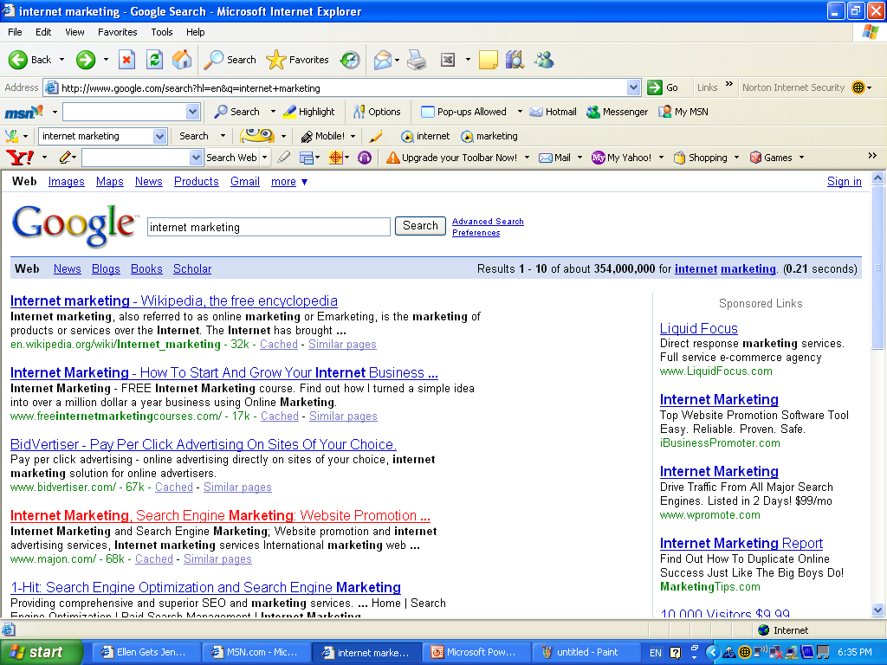

[Search Engine Optimization](http://en.wikipedia.org/wiki/Search_Engine_Optimization), or SEO, attempts to improve a website's organic search rankings in SERPs by increasing the website content's relevance to search terms. Search engines regularly update their algorithms to penalize poor quality sites that try to game their rankings, making optimization a moving target for advertisers. Many vendors offer SEO services.

**Sponsored search**

[Sponsored search](http://en.wikipedia.org/wiki/Search_engine_marketing#Paid_inclusion) (also called sponsored links or search ads) allows advertisers to be included in the sponsored results of a search for selected keywords. Search ads are often sold via real-time auctions, where advertisers bid on keywords. In addition to setting a maximum price per keyword, bids may include time, language, geographical, and other constraints. Search engines originally sold listings in order of highest bids. Modern search engines rank sponsored listings based on a combination of bid price, expected click-through rate, keyword relevancy, and site quality.

**Social media marketing**

[Social media marketing](http://en.wikipedia.org/wiki/Social_media_marketing) is commercial promotion conducted through [social media](http://en.wikipedia.org/wiki/Social_media) websites. Many companies promote their products by posting frequent updates and providing special offers through their social media profiles.

**Image 2.General social media and Internet stats**



**Social media for business statistics**

27% of small and 34% of medium businesses are using social media for business (+10% Year on Year)

* 25% of SMBs have no strategy and only 28% of small and 24% of medium businesses measure their ROI of social media activity
* Social media users who receive excellent customer service from brands spend on average 21% more than non-social customers
* 83% of socially savvy consumers have walked away from a purchase in the past year after a negative customer service experience – compared with 49% of everyone else
* 80% of businesses use social media sites to monitor/extract information relating to competitors
* Only 44% of customer questions on twitter are answered within 24 hours
* 56% of customer tweets to companies are being ignored
* 55% of consumers share their purchases socially on Facebook, Twitter, Pinterest and other social sites
* Facebook is most popular site to share online purchases (55%), Twitter (22%), Pinterest (14%), Instagram (5%) and LinkedIn (3%)
* 59% of Pinterest users have purchased an item they saw on the site, 33% of Facebook users have purcahsed an item they saw on their news feed or a friend’s wall
* 79% of Pinterest users are more likely to purchase items they’ve seen on Pinterest compared with Facebook users purchasing behavior
* 64% of Facebook users have clicked on a Facebook ad, but only one-fourth of these users actually converted and bought an item
* when making online purchases, 66% of consumers prefer to purchase from a retailer’s online site, vs. its app
* There are over 10 million social mentions of the Fortune 100 each month<
* With Twitter generating the most amount of chatter
* 87% of the Fortune 100 now use social media – with twitter the most popular
* Tweet volumes tripled in the last 12 months
* 75% of the Fortune 100 are on Facebook
* Each corporate YouTube Channel averages 2million views
* Fortune 100 Companies are creative multiple accounts per platform / per region
* 50% of Fortune 100 Companies have a Google+ Account
* 25% have a Pinterest Account
* Facebook is the number one social marketing tool for brands at 83% (88% target for 2014), followed by Twitter at 53% (target 64% in 2014)
* On average companies respond to only 30% of social media fans’ feedback
* By 2016 more than half of the dollars spent in US retail will be influenced by the web  42% of employers say no to any use of social media in the workplace
* 40% of young workers rate access to social media at work abovereceiving a higher salary
* 53% of employers have a formal policy on social media
* 59% of media companies actively encourage their employees to use social media
* 71% of energy companies prohibit any use of social media at work
* Over 50% of workers aged over 50 use social media every day at work (
* 73% of Fortune 500 companies have a Twitter account
* 66% of Fortune 500 companies have a Facebook page
* 18 different countries across Asia, including Australia, China, Hong Kong, India, Indonesia, Japan, Malaysia, South Korea and Thailand discovered that Facebook (88.8 %), Twitter (66.4%) and YouTube (62.4%) were the social platforms of choice amongst all respondents.
* LinkedIn (40%) finished fourth, ahead of blogs (39.2%) and Pinterest (20.8%), with Google+ being used by just 12.8% of Asian corporate marketers.
* 94% of corporates use social media and 85% say it’s given their business more exposure
* 74% of brand marketers saw an increase in website traffic after investing just 6 hours per week on social media
* 61% of corporates still rate blogging overall, 23% of Fortune 500 companies actively maintain a corporate blog
* 76% of corporate marketers plan to increase their use of YouTube or other video marketing
* 65% of corporate marketers use social media to gain market intelligence
* 24% of the top 10,000 websites in the world use some form of official Facebook integration on their homepage (if standard links to Facebook Pages is included this jumps to 49%)
* 42% of the top 10,000 websites have some form of Twitter link on their homepage, just 4% use Twitter’s share button and only 10% utilize any official Twitter widgets
* The Facebook Like button is used on 7% of the top 10,000 homepages
* LinkedIn is featured on just 0.6% of the top 10k websites (0.3% using the LinkedIn share button)
* People are 25% more likely to buy a product that they would be proud to own if it has social media buttons next to it
* People are 25% less likely to buy an embarrassing product if it’s placed anywhere near a social sharing tool
* 70% of brands ignore complaints on Twitter
* 83% of people who complained on Twitter loved the response from those companies that did make the effort
* Only 26% of businesses regularly include a call to action in their tweets
* 42% of marketers believe Facebook is critical or important to their business (+75% since 2009)
* 62% of marketers say social media became more important to their marketing campaigns in the last six months
* Social media has a 100% higher lead-to-close rate than outbound marketing
* 77% of B2C companies have acquired customers from Facebook vs 42% of B2B
* Retail is the top industry that has acquired customers through Facebook (over 90%)
* 80% of US social network users prefer to connect to brands through Facebook
* Brands have seen a 46% increase in user engagement with the new Timeline format in Facebook
* Auto-posting to Facebook decreases likes and comments by 70%
* Facebook is responsible for 86% of social referrals, Pinterest 11% and Twitter 3%
* Facebook users generate 2.5 times more page views than Twitter and almost twice as many as Pinterest (FB 7, Pinterest 4.1, Twitter 2.7)
* Conversion rates for Facebook traffic: 2.6%, Pinterest 0.9% and Twitter 1.1%
* Average order value (AOV): FB $2.50, Pinterest $1.60, Twitter 80c
* 25% of Twitter users connect with a brand on the platform (over one third of these do so for discounts and promotions)
* Over 25% of Twitter users would consider contacting a business via the platform
* Over half of social networking users who share business-related content do so on Twitter
* 39% of companies do not track their social media responses at all, and 55% ignore all customer feedback on Twitter and Facebook, largely because they have no process in place to respond.
* What do people want from brands on social media? ….
  + 83% want deals and promotions
  + 70% want rewards programs
  + 58% want exclusive content
  + 55% want feedback on new products

**Mobile marketing or advertising**

[Mobile marketing](http://en.wikipedia.org/wiki/Mobile_advertising) is ad copy delivered through wireless mobile devices such as [smart phones](http://en.wikipedia.org/wiki/Smartphone), [feature phones](http://en.wikipedia.org/wiki/Feature_phone), or tablet computers. Mobile marketing may take the form of static or rich media display ads, SMS (Short Message Service) or [MMS](http://en.wikipedia.org/wiki/Multimedia_Messaging_Service) (Multimedia Messaging Service) ads, mobile search ads, advertising within mobile websites, or ads within mobile applications or games (such as interstitial ads, “averaging,” or application sponsorship). Industry groups such as the Mobile Marketing Association have attempted to standardize mobile ad unit specifications, similar to the IAB's efforts for general online advertising.

Mobile marketing is growing rapidly for several reasons. There are more mobile devices in the field, connectivity speeds have improved (which, among other things, allows for richer media ads to be served quickly), screen resolutions have advanced, mobile publishers are becoming more sophisticated about incorporating ads, and consumers are using mobile devices more extensively. The Interactive Advertising Bureau predicts continued growth in mobile advertising with the adoption of location-based targeting and other technological features not available or relevant on personal computers.

***Mobile advertising*** is a form of advertising via mobile (wireless) phones or other mobile devices. It is a subset of mobile marketing.

Some see mobile advertising as closely related to online or internet advertising, though its reach is far greater - currently, most mobile advertising is targeted at mobile phones, that came estimably to a global total of 4.6 billion as of 2009. Notably computers, including desktops and laptops, are currently estimated at 1.1 billion globally.

It is probable that advertisers and media industry will increasingly take account of a bigger and fast-growing mobile market, though it remains at around 1% of global advertising spend. Mobile media is evolving rapidly and while mobile phones will continue to be the mainstay, it is not clear whether mobile phones based on cellular backhaul or smartphones based on WiFi hot spot or WiMAX hot zone will also strengthen. However, such is the emergence of this form of advertising, that there is now a dedicated global awards ceremony organised every year by Visiongain.

As mobile phones outnumber TV sets by over 3 to 1, and PC based internet users by over 4 to 1, and the total laptop and desktop PC population by nearly 5 to 1, advertisers in many markets have recently rushed to this media. In Spain 75% of mobile phone owners receive ads, in France 62% and in Japan 54%. More remarkably as mobile advertising matures, like in the most advanced markets, the user involvement also matures. In Japan today, already 44% of mobile phone owners click on ads they receive on their phones. Mobile advertising was worth 900 million dollars in Japan alone. According to the research firm Berg Insight the global mobile advertising market that was estimated to € 1 billion in 2008. Furthermore, Berg Insight forecasts the global mobile advertising market to grow at a compound annual growth rate of 43 percent to € 8.7 billion in 2014.

It is reported that mobile advertising is growing globally at a rapid rate. Rich media ads are now averaging a 1.53 percentage click rate among users. In app large banner ads are still the most popular, but they are on the decline

**Figure 1. Types of mobile marketing**

Here will be explained some types of mobile marketing channels that can be useful for tourism and hospitality industry, depending on their target audience preferences:

❖ SMS(short message service): Advertisers can send relevant marketing messages in form of texts;

❖ MMS(multi-media message service): Marketing messages that utilize multiple, rich media elements such as images, video and audio;

❖ Mobile Applications: apps are a good way to connect with consumers, as they can be easier to use than the mobile web. Some apps allow for adverts within the applications design too;

❖ Bluetooth Proximity: Marketing: utilizes Bluetooth to connect with a marketers broadcasting station and station is programmed to automatically deliver content to the consumer’s phone. It automatically authenticates its make and model and sends the content;

❖ Location-Based Marketing: Delivers multi-media directly to the user of a mobile device dependent upon their location via GPS technology;

❖ QR Codes(quick-response barcodes): Allows customers to quickly learn more about a business, by visiting a mobile version of their business page on a mobile phone that is enabled to scan the bar code;

❖ PPC (Pay Per Call) Mobile Marketing: These are usually advertisements that require the customer to perform a certain action like making a phone call usually with the provided number that the ad gives. If the customer makes a call to that number they are then billed;

❖ Voice Marketing: Voice broadcasting calls numbers from a computer managed list and plays a pre-recorded message to the customer;

❖ Mobile Web: Having a mobile friendly version of your website is increasingly important as more and more people start to use their mobiles to search online;

❖ Mobile Banner Ads: Like standard banner ads for desktop web pages but smaller to fit on mobile screens and run on the mobile content network.

As you can see there are lots of ways into mobile marketing. Mobile web and banner ads are good for finding new customers, whereas SMS marketing and MMS are great for interacting with your existing client base and directing them to your mobile site or apps.

In the coming years a major trend in this industry will represent the advertising via social networks on mobile devices. In other words, the potential of this market is really huge and leaders in the tourism and hospitality industry are slowly becoming aware of it.

**Email Advertising**

Email advertising is ad copy comprising an entire email or a portion of an email message. Email marketing may be unsolicited, in which case the sender may give the recipient an option to opt-out of future emails, or it may be sent with the recipient's prior consent (opt-in).

**Chat advertising**

As opposed to static messaging, chat advertising refers to real time messages dropped to users on certain sites. This is done by the usage of live chat software or tracking applications installed within certain websites with the operating personnel behind the site often dropping adverts on the traffic surfing around the sites. In reality this is a subset of the email advertising but different because of its time window.

**Online classified advertising**

Online classified advertising is advertising posted online in a categorical listing of specific products or services. Examples include online job boards, online real estate listings, automotive listings, online [yellow pages](http://en.wikipedia.org/wiki/Yellow_pages), and online auction-based listings. [Craigslist](http://en.wikipedia.org/wiki/Craigslist) and [eBay](http://en.wikipedia.org/wiki/EBay) are two prominent providers of online classified listings.

**Adware**

[Adware](http://en.wikipedia.org/wiki/Adware) is software that, once installed, automatically displays advertisements on a user's computer. The ads may appear in the software itself, integrated into web pages visited by the user, or in pop-ups/pop-under. Adware installed without the user's permission is a type of [malware](http://en.wikipedia.org/wiki/Malware).

**Affiliate Marketing**

Affiliate marketing (sometimes called lead generation) occurs when advertisers organize third parties to generate potential customers for them. Third-party affiliates receive payment based on sales generated through their promotion.

*Online marketing*, also called Internet advertising, uses the Internet to deliver promotional marketing messages to consumers. It includes *email marketing, search engine marketing, social media marketing, many types of display advertising (including web banner advertising),* and *mobile advertising*.

Like other advertising media, marketing frequently involves both a publisher, who integrates advertisements into its online content, and an advertiser, who provides the advertisements to be displayed on the publisher's content. Other potential participants include advertising agencies who help generate and place the ad copy, an ad server who technologically delivers the ad and tracks statistics, and advertising affiliates who do independent promotional work for the advertiser.

***Online advertising*** is a large business and is growing rapidly. In 2011, Internet advertising revenues in the United States surpassed those of cable television and nearly exceeded those of broadcast television. In 2012, Internet advertising revenues in the United States totaled $36.57 billion, a 15.2% increase over the $31.74 billion in revenues in 2011. U.S. internet ad revenue hit a historic high of $20.1 billion for the first half of 2013, up 18% over the same period in 2012. Online advertising is widely used across virtually all industry sectors.

Despite its popularity, many common online advertising practices are controversial and increasingly subject to regulation. Furthermore, online ad revenues may not adequately replace other publishers' revenue streams. Declining ad revenue has led some publishers to hide their content behind pay walls.

**1.2. The impact of e-commerce on the efficiency of the economy around the world.**

In 2013, the United Kingdom had the biggest e-commerce market in the world when measured by the amount spent per capita. The Czech Republic is the European country where e-commerce delivers the biggest contribution to the enterprises´ total revenue. Almost a quarter (24%) of the country’s total turnover is generated via the online channel.

Among emerging economies, China's e-commerce presence continues to expand every year. With 384 million internet users, China's online shopping sales rose to $36.6 billion in 2013 and one of the reasons behind the huge growth has been the improved trust level for shoppers. The Chinese retailers have been able to help consumers feel more comfortable shopping online. China's cross-border e-commerce is also growing rapidly. E-commerce transactions between China and other countries increased 32% to 2.3 trillion Yuan ($375.8 billion) in 2012 and accounted for 9.6% of China's total international trade. In 2013, Alibaba had an e-commerce market share of 80% in China.

Other BRIC (Brazil, Russia, India and Chine) countries are witnessing the accelerated growth of e-commerce as well. Brazil's e-commerce is growing quickly with retail e-commerce sales expected to grow at a healthy double-digit pace through 2014. By 2016, e-marketer expects retail ecommerce sales in Brazil to reach $17.3 billion. India has an internet user base of about 243.2 million as of January 2014. Despite being third largest user base in world, the penetration of Internet is low compared to markets like the United States, United Kingdom or France but is growing at a much faster rate, adding around 6 million new entrants every month. The industry consensus is that growth is at an inflection point. In India, cash on delivery is the most preferred payment method, accumulating 75% of the e-retail activities.

E-Commerce has become an important tool for small and large businesses worldwide, not only to sell to customers, but also to engage them. In 2013, ecommerce sales topped $1 trillion for the first time in history. Mobile devices are playing an increasing role in the mix of e-commerce. Some estimates show that purchases made on mobile devices will make up 25% of the market by 2017. According to Cisco Visual Networking Index, in 2014 the amount of mobile devices has outnumbered the number of world population.

In the past 10 years, e-commerce is in a period of rapid development. Cross-border e-commerce is called the Internet thinking along with traditional import and export trade. Cross-border e-commerce enables international trade towards more convenient and free open to cooperate between different countries in the world, incorporating developed and developing countries. In the short term, developing countries may be limited to IT, but in the long term, they would change the barrier to develop their IT facilities, and continuing to close to developed countries. The moment, developing countries like China and India are developing e-commerce very rapidly, such as China 's Alibaba, the financing capital (£15 billions) is the highest ever in e-commerce company. In addition, China is becoming the biggest e-commerce provider in the world. The number of Internet users in China which amounts to 600 million, and which is doubled than USA users in total.

For traditional businesses, one research stated that information technology and cross-border e-commerce is a good opportunity for the rapid development and growth of enterprises. Many companies have invested enormous volume of investment in mobile applications. The DE Lone and McLean Model stated that 3 perspectives are contributed to a successful e-business; including information system quality, service quality and users satisfaction. There is no limit of time and space, there are more opportunities to reach out to customers around the world, and to cut down unnecessary intermediate links, thereby reducing the cost price, and can benefit from one on one large customer data analysis, to achieve a high degree of personal customization strategic plan, in order to fully enhance the core competitiveness of the products in company

Economists have theorized that e-commerce ought to lead to intensified price competition, as it increases consumers' ability to gather information about products and prices. Research by four economists at the University of Chicago has found that the growth of online shopping has also affected industry structure in two areas that have seen significant growth in e-commerce, bookshops and travel agencies. Generally, larger firms are able to use economies of scale and offer lower prices. The lone exception to this pattern has been the very smallest category of bookseller, shops with between one and four employees, which appear to have withstood the trend.

Individual or business involved in e-commerce whether buyers or sellers rely on Internet-based technology in order to accomplish their transactions. E-commerce is recognized for its ability to allow business to communicate and to form transaction anytime and anyplace. Whether an individual is in the US or overseas, business can be conducted through the internet. The power of e-commerce allows geophysical barriers to disappear, making all consumers and businesses on earth potential customers and suppliers. EBAY is a good example of e-commerce business individuals and businesses are able to post their items and sell them around the Globe.

In e-commerce activities, supply chain and logistics are two most crucial factors need to be considered. Typically, cross-border logistics need about few weeks’ time round. Based on this low efficiency of the supply chain service, customer satisfaction will be greatly reduced.  Some researcher stated that combining e-commerce competence and IT setup could well enhance company’s overall business worth.  Other researcher stated that e-commerce need to consider the establishment of warehouse centers in foreign countries, to create high efficiency of the logistics system, not only improve customers’ satisfaction, but also can improve customers’ loyalty.

Some researcher investigated that if a company want to enhance international customers’ satisfaction, where cultural website need to be adapted in particular country, rather than solely depending on its local country. However, according to these research findings, the researcher found that German company had treated its international website as the same local model, such as in UK and US online marketing.  A company could save money and make decision quickly via the identical strategy in different country. However, opportunity cost could be occurred, if the local strategy does not match to a new market, the company could lose its potential customer.

For a long time, companies had been troubled by the gap between the benefits which supply chain technology has and the solutions to deliver those benefits. However, the emergence of e-commerce has provided a more practical and effective way of delivering the benefits of the new supply chain technologies. E-commerce has the capability to integrate all inter-company and intra-company functions, meaning that the three flows (physical flow, financial flow and information flow) of the supply chain could be also affected by e-commerce. The affections on physical flows improved the way of product and inventory movement level for companies. For the information flows, e-commerce optimized the capacity of information processing than companies used to have, and for the financial flows, e-comers allows companies to have more efficient payment and settlement solutions.

In addition, e-commerce has a more sophisticated level of impact on supply chains: Firstly, the performance gap will be eliminated since companies can identify gaps between different levels of supply chains by electronic means of solutions; Secondly, as a result of e-commerce emergence, new capabilities such implementing ERP systems have helped companies to manage operations with customers and suppliers. Yet these new capabilities are still not fully exploited. Thirdly, technology companies would keep investing on new e-commerce software solutions as they are expecting investment return. Fourthly, e-commerce would help to solve many aspects of issues that companies may feel difficult to cope with, such as political barriers or cross-country changes. Finally, e-commerce provides companies a more efficient and effective way to collaborate with each other within the supply chain.

Along with the e-marketing and its unique charm that has appeared gradually, virtual enterprise, virtual bank, network marketing, online shopping, payment and advertising, such this new vocabulary which is unheard-of and now has become as familiar to people. This reflects that the e-marketing has huge impact on the economy and society from the other side. For instance, B2B is a rapidly growing business in the world that leads to lower cost and then improves the economic efficiency and also bring along the growth of employment.

To understand how the e-commerce has affected the society and economy, this article will mention three issues below:

1. The e-commerce has changed the relative importance of time, but as the pillars of indicator of the country’s economic state that the importance of time should not be ignored.

2. The e-commerce offers the consumer or enterprise various information they need, making information into total transparency, will force enterprise no longer is able to use the mode of space or advertisement to raise their competitive edge. Moreover, in theory, perfect competition between the consumer sovereignty and industry will maximize social welfare.

3. In fact, during the economic activity in the past, large enterprise frequently has advantage of information resource, and thus at the expense of consumers. Nowadays, the transparent and real-time information protects the rights of consumers, because the consumers can use internet to pick out the portfolio to the benefit of them. The competitiveness of enterprises will be much more obvious than before, consequently, social welfare would be improved by the development of the e-commerce.

4. The new economy led by the e-commerce change humanistic spirit as well, but above all, is the employee loyalty. Due to the market with competition, the employee’s level of professionalism becomes the crucial for enterprise in the niche market. The enterprises must pay attention to how to build up the enterprises inner culture and a set of interactive mechanisms and it is the prime problem for them. Furthermore, though the mode of e-commerce decrease the information cost and transaction cost, however, its development also makes human being are overly computer literate. In hence, emphasized more humanistic attitude to work is another project for enterprise to development. Life is the root of all and high technologies are merely an assistive tool to support our quality of life.

**1.3. The real advantages and disadvantages of online marketing.**

This is a matter that is gaining strength lately, the moment when the social networks hoard thousands of users with different social, economic, cultural and political interests. Let’s see what are the real advantages and disadvantages of online marketing.

One of the most important advantages is the fast availability of the information. The clients/users can easily get information, by navigating the internet, about the products that they wish to purchase, and besides that, they can check the information at any time of the day. It allows the companies to save money, an aspect that is really taken into account by the companies since the online marketing campaigns don’t require a large amount of investment.

The previous mentioned aspect, gives less importance to the differences between large and small companies in some way, thus increasing the competition and giving that way advantages to the customers. Presence on the Internet can help the expansion of the company from a local market to national and international markets at the same time, offering almost infinite expanding possibilities. On the internet everything can be measured, thus it’s easier for the companies to know almost instantly if their campaign is working or not, what company or user is interested in their products, from what cities or countries are they, etc.

Slow internet connections can cause difficulties. If the companies build too complex or too large websites, it will take too long for users to check them or download them and they will get bored eventually.

The e-commerce doesn’t allow the user “to touch” the merchandise before purchasing it. Because of this, some salesmen are starting to guarantee the possibility of returning the product. In Germany, where a law that regulates e-commerce and guarantees the customers the total refund of the money exists since 2000, the electronic commerce is very popular. Other factor is the payment: many users still don’t trust in the electronic methods of paying and give up buying online because of this.

One of the major disadvantages may be the lack of trust of the users because of the constant virtual promotions that appear to be frauds. This is an aspect that deteriorates the image and reputation of quality and honest companies.

Other disadvantage is the cash on delivery system, since it doesn’t guarantee the 100% purchase of the product. This is also the case of thousands of users that dedicate themselves to daily mock big companies by ordering on the internet using false identities.

However, the term is usually used to identify:  
- sending email messages with the purpose of create the relationship of a marketer with his existing or previous customers, to motivate customer loyalty and thereby to continue already existing business relationships  
- sending email messages with the purpose of getting new customers or assuring existing customers to purchase service or product immediately  
-adding some advertisement to email messages sent by other companies to their customers  
-sending email messages over the Internet  
 As it is known, email marketing has its advantages and disadvantages.

 Its advantages lie in the fact that it is popular in many companies.

-E- marketing in comparison with other means of traditional advertisement such as billboard and broadsheet set up or tracts and products samples spreading proved its cost effectiveness.  
-The company shouldn't expend money on advertisement. All it needs is Internet and email lists of potential or existing customers.  
- E- marketing is fast in it nature. You spend minimum time for email marketing campaign reaching fast results.  
-Advertisers can reach a substantial number of customers who already gave their consent to receive such emails and are interested in the services or products that are advertised.   
-Using Internet more than a half of its users check their mail box every day. Thereby, the company may acquire more and more customers every day, week or even month.  
-Opt-in marketing is undoubtedly effective. That means you already have persons' permission to receive emails from you. Knowing your company, its services and products they are interested in new information from you. These existing relationships are not to be reestablished!

The primary purpose of a transactional email is to convey information regarding the action that triggered it. But, due to its high open rates (51.3% compared to 36.6% for email newsletters), transactional emails are an opportunity to engage customers: to introduce or extend the email relationship with customers or subscribers, to anticipate and answer questions or to cross-sell or up-sell products or services.

Many email newsletter software vendors offer transactional email support, which gives companies the ability to include promotional messages within the body of transactional emails. There are also software vendors that offer specialized transactional email marketing services, which include providing targeted and personalized transactional email messages and running specific marketing campaigns

Direct e-mails

Direct email or interruption based marketing involves sending an email solely to communicate a promotional message (for example, an announcement of a special offer or a catalog of products). Companies usually collect a list of customer or prospect email addresses to send direct promotional messages to, or they can also rent a list of email addresses from service companies, but safe mail marketing is also used.

Comparison to traditional mail

There are both advantages and disadvantages to using email marketing in comparison to traditional [advertising mail](http://en.wikipedia.org/wiki/Advertising_mail).

Email marketing is popular with companies for several reasons:

An exact return on investment can be tracked ("track to basket") and has proven to be high when done properly. Email marketing is often reported as second only to search marketing as the most effective online marketing tactic.Email marketing is significantly cheaper and faster than traditional mail, mainly because of high cost and time required in a traditional mail campaign for producing the artwork, printing, addressing and mailing.

Advertisers can reach substantial numbers of email subscribers who have opted in to receive email communications on subjects of interest to them. Almost half of American [Internet](http://en.wikipedia.org/wiki/Internet) users check or send email on a typical day, with email blasts that are delivered between 1 am and 5 am local time outperforming those sent at other times in open and click rates. Email is popular with digital marketers, rising an estimated 15% in 2013 to £292 m in the UK. If compared to standard email, direct email marketing produces higher response rate and higher average order value for e-commerce businesses.

A report issued by the email services company Return Path, as of mid-2013 email deliverability is still an issue for legitimate marketers. According to the report, legitimate email servers averaged a delivery rate of 56%; twenty percent of the messages were rejected, and eight percent were filtered.

Companies considering the use of an email marketing program must make sure that their program does not violate spam laws such as the United States' Controlling the Assault of Non-Solicited Pornography and Marketing Act the European Privacy and Electronic Communications Regulations 2013, or their Internet service provider's acceptable use policy.

Opt-in email advertising

Opt-in email advertising, or permission marketing, is a method of advertising via email whereby the recipient of the advertisement has consented to receive it. This method is one of several developed by marketers to eliminate the disadvantages of email marketing.

Opt-in email marketing may evolve into a technology that uses handshake between the sender and receiver. This system is intended to eventually result in a high degree of satisfaction between consumers and marketers. If opt-in email advertising is used, the material that is emailed to consumers will be "anticipated." It is assumed that the consumer wants to receive it, which makes it unlike unsolicited advertisements sent to the consumer. Ideally, opt-in email advertisements will be more personal and relevant to the consumer than untargeted advertisements.

A common example of permission marketing is a newsletter sent to an advertising firm's customers. Such newsletters inform customers of upcoming events or promotions, or new products. In this type of advertising, a company that wants to send a newsletter to their customers may ask them at the point of purchase if they would like to receive the newsletter. With a foundation of opted-in contact information stored in their database, marketers can send out promotional materials automatically using auto responders—known as Drip Marketing. They can also segment their promotions to specific market segments.

**Chapter II. The contribution of E-marketing in the field of hotel industry**.

**2.1. A successful E-marketing strategies and its main roles for a hectic world.**

E-marketing is also known as Internet marketing, web marketing, e-commerce, online marketing or digital marketing. It is growing at a dramatic pace in the hospitality industry and is significantly impacting the business behaviors since it drives more revenue than traditional marketing. A successful e-marketing strategy should comprise a set of specific e-actions that help hoteliers reach their planned objectives. These e-actions can be grouped into the following five main sections:

(A to E): A/ Search Engine Marketing (SEM): The large majority of Internet surfers use search engines to find information about hotels or travel destinations online. This makes search engines one of the most effective tools in driving targeted traffic to a hotel’s or destination’s website. In the hospitality sector, hoteliers have two options with regard to SEM: Search Engine Optimization (SEO) or sponsored search. SEO is the process of affecting the visibility of a website or a web page. SEO may target different kinds of search, including image search, local search, and video search and so on. As an Internet marketing strategy SEO considers how search engines work, what people search for the actual search terms or keywords typed into search engines and which search engines are preferred by their targeted audience.

A-1/Search Engine Optimization (SEO): SEO attempt to improve a website’s organic (i.e. non-sponsored) search rankings in Search Engine Results Pages (SERPs) by increasing the content’s relevance to search terms. Several techniques are recommended with regard to SEO: The Conversion Optimizer: This technique helps to assess, through several testing methods, how to increase the website’s conversion rate. That is, the probability that a website visit leads to an effective booking.

Optimization of HTML elements: HTML (Hyper Text Markup Language is a standard markup language used to create web pages ) elements, apart from keywords and site design, play a major role in SEO since they are the cornerstone upon which all websites are built. HTML elements comprise title, Meta description, Header tags, image name, Alt tags; internal linking, etc. Content optimization for Search Engine: While the website’s content should match the guests’ search criteria, many hoteliers fail in making their websites a dumping ground for content to end up with websites that generate very poor value to guests and very low business opportunities. The process of content optimization for search engine starts with the identification of “Long neck” and “Long tail” keywords: Long neck keywords are the website’s theme-related keywords which are heavily searched by the target guests by opposition to the Long tail ones. Examples of Long neck keywords might include, for instance, “find a price”, “book a room”, “hotel location” while examples of long tail keywords might include terms like “get warranty info”, “get e-newsletter”, “find a job”, etc. Content optimization for search engine is all about distinguishing between “Killer content” (the core of visitors’ needs) that should be clearly showcased on a website since it responds to “long neck” keywords, and “Filler content” that should occupy less space since it responds to “long tail” keywords.

The final aim is to make sure that guests won’t get lost on the website and that they will quickly find what they came for in as less button-clicks as possible. A-2/Sponsored search: Sponsored search corresponds to search ads that allow a hotel /chain to be included in the sponsored results of a search for selected keywords. This action is generally undertaken through a bidding process on keywords. The Search Engines provide the mechanism for the sponsored search process to occur.

This process is continually evolving and gaining complexity year on year. The payment methods for sponsored search include the Cost Per Mille (CPM), the Cost Per Click method (CPC), Pay Per Performance (PPP) (also called “Cost Per Action” or “Cost Per Acquisition” (CPA)) and fixed costs (i.e. fixed-cost compensation). B/Social Media marketing: Social Media websites such as Face book, Twitter, YouTube,… possess the advantage that they can spread any information or update posted rapidly to a very wide audience. Furthermore, sharable videos (i.e. choosing an engaging storyline and telling it with compelling visuals) constitute an amazing tool that keeps users’ attention and subtly persuade them along the way words can’t.

Moreover, the implementation of Web 2.0 services has significantly contributed in transforming hotels’/hotel chains’ websites into social platforms to feature user-generated content. This enables guests to share their stories, photos and experiences which instantly foster word of mouth. Several international hotel chains have very efficient marketing implementation of social media. Starwood, for instance, introduced a new quantitative tool called “Reputation Management Index” (RMI) which, through review analysis from all social media, provides a lot of valuable data that can be used not only for service improvements but also for competitive insights. Besides, Starwood implemented efficient Review Management Responses to foster instant reviews any time. C/ Mobile advertising: Mobile advertising is growing rapidly since mobile devices have multiplied, connectivity speeds have improved and screen resolutions have advanced. For these reasons, the online experience should be seamless across devices. An efficient action plan for a successful mobile advertising should include the following actions: Interface design: Adjustment of the web content for screen size so that users can comfortably access content in an intuitive way on a smaller screen and benefit from all functionalities on a mobile device (hotel search, access to reviews, bookings, payments, etc.).

Study of people’s behavior: This aims at the examination of “when”, “where” and “why” people use Smart phones and tablets to better understand their booking trend, needs and expectations. Deals with Google: To generate fast growing Google search traffic to the hotel website from mobile. QR codes’ use implementation: QR codes (Quick Response codes) represent a tremendous tool at the disposal of hoteliers to use for marketing purposes and also for customer service improvement. By displaying QR codes at the concierge desk, in elevators or at the back of a room card, hoteliers are offering their in-house guests the possibility to get automatically diverted, upon scanning these codes via their mobile devices, to a limitless supply of digital content (e.g. benefit from special offers, get valuable recommendations on the city attractions and night life, etc.). Another interesting use of QR codes might include the creation of a mobile review page to be linked to a QR code on the hotel bill so that guests get encouraged to write their reviews while their memories are still fresh. This certainly improves reviews’ accuracy and consequently customer service. D/ Email advertising: Email advertising, also known as email marketing, is considered as a powerful e-marketing tool for hoteliers since it creates direct revenue opportunities for past, present and future guests.

However, as emails and/or e-newsletters might be unsolicited, senders should either offer recipients an opt-out option or get their prior consent (opt-in). In fact, experience shows that permission-based email marketing is one of the most cost-effective and efficient marketing tools available. The benefits of email marketing can be summarized as follows: Serves both as direct-response vehicle and branding tool. Creates personalized interactive relationships. Targets and entices recipients with relevant promotions. Plants seed in the mind of recipients regarding future travel. Serves as a tool to move distressed inventory. Functions as a sales force since it reaches thousands in seconds. Recruits new customers and retain old ones. E/ Display advertising:

Display advertising conveys its advertising message visually using text, logos, animations, videos, photographs or other graphics. The most common two display advertising techniques are the following: Web banner advertising (or banner ads): They are typically graphic ads displayed within a web page. They use rich media to incorporate video, audio, animations or other interactive elements. These include Frame ad, Pop-ups/pop-under, floating ad, Expanding ad, Trick banners, etc. Text ads: A text ad displays text-based hyperlinks.

Text-based ads may display separately from the web page’s primary content or they can be embedded by hyper linking individual words or phrases to a hotel’s website. The online marketing is doubtless one of nowadays most powerful advertising methods. All companies, and notably in the Tourism and Hospitality industry, are fiercely competing to lead and overwhelm the online space in order to shift market shares from competition, increase their online traffic and make more profits. In addition,

International hotel chains are considerably reducing their offline marketing budgets year on year for the benefit of the online ones. However, it is always required for any company wishing to succeed its e-marketing strategy, to ensure that all of its online space is well managed and that it is entirely under control. Moreover, updates and innovations in the online world are a must to attract customers and keep their interest constantly stimulated.

Social media marketing is the process of gaining website traffic or attention through social media sites. Social media marketing programs usually center on efforts to create content that attracts attention and encourages readers to share it across their social networks. The resulting electronic word of mouth (eWoM) refers to any statement consumers share via the Internet (e.g., web sites, social networks, instant messages, news feeds) about an event, product, service, brand or company. When the underlying message spreads from user to user and presumably resonates because it appears to come from a trusted, third-party source, as opposed to the brand or company itself, this form of marketing results in earned media rather than paid media.

**2.2. Online marketing in tourism destination.**

Tourism is an industry with the nature of information-intensive and it demands an important role of internet communication technologies in the promotion and marketing of destinations. At the present time, Internet has become a primary tool for the delivery of information. In a burgeoning market, competitiveness takes advantage. Therefore nearly all major markets use Internet as a marketing medium. The online marketing of DOMs gives a platform for visitors to access information and to communicate with others, furthermore the online marketing also offers DOMs more opportunities to reach both existing and potential visitors than ever before.

Destination Marketing Organizations (DMOs)

According to Pike (2008), a destination marketing organization (DMO) is the organization which is responsible for the marketing of an identifiable destination. This therefore excludes separate government departments that are responsible for planning and policy, and private sector umbrella organizations.

Most tourism activities take place at destinations. It has even been suggested that destinations have emerged as “the fundamental unit of analysis in tourism”, and form a pillar in any modeling of the tourism system (WTO, 2002). Some studies indicate clearly that destination marketing organizations (DMOs) are concerned with the selling of places (Pike, 2008). Nowadays, travelers are offered a mass of choices by the destinations. Therefore all the destinations are facing the challenges: How to attract travelers? How to enhance the long term competitiveness of the destination? DMO is considered as a major solution to solve the challenges. Pike (2008) pointed out that the purpose of any DMO is to foster sustained destination competitiveness.

The research uses the case study of Visit Sweden as the DMO of Sweden. Visit Sweden is a communications company half-owned by the Swedish state, through the Ministry of Enterprise, Energy and Communications and half-owned by the Swedish tourism industry, through Svensk Turism AB (Visit Sweden, 2011). As the official DMO of Sweden,

The assignment of Visit Sweden focuses on both the international marketing of the Swedish brand and the foreign marketing of Swedish destinations and experiences. Visit Sweden applied itself to promote a positive image of Sweden, the whole organization works closely with foreign operators and the Swedish tourism industry. Visit Sweden also develops the collaboration with the other members of the Council for the Promotion of Sweden Abroad. By sharing the information from different offices, Visit Sweden can strengthen its competiveness in the market and as a result increase sales in the tourism industry.

In contemporary travel agencies and tour operators business, the Internet has shown to be a profitable medium of tourism promotion and sales.

* The Internet represents an interesting and useful distribution channel for collecting clients and it provides the ability to identify their desires.
* Promotional visualization of tourism services and products through multimedia technology leaves greater impression on potential customer than standard brochures, catalogues and leaflets.
* Overbooking has become almost impossible because all communication problems that may cause it are removed.
* The Internet allows the improvement of travel agencies and tour operators by speeding up communication and providing all the necessary information.
* Product distribution and services of agencies do not depend on the quantity of printed catalogues anymore and information about them can reach millions of the Internet users.
* The Internet provides selling services of travel agencies on demand.
* CRS/GDS (Central Reservation system/ Global Distribution) allow better and more efficient business with clients to contemporary travel agencies.

*‘*Greater added values which agencies, by using the Internet, can provide to clients are high-quality information, quick offer of services related to travel, fast order, express delivery and human personality”

Ruelcke, W., 2000

Use of the Internet in contemporary travel agencies business has certain drawbacks such as: web information is not always complete and reliable, payment security is still not on the satisfactory level, and the sale of certain products and services demands direct communication with the travel agent.

**2.3 The social impact of e-marketing for hotel sphere**

Along with the e-marketing and its unique charm that has appeared gradually, virtual enterprise, virtual bank, network marketing, online shopping, payment and advertising, such this new vocabulary which is unheard-of and now has become as familiar to people. This reflects that the e-marketing has huge impact on the economy and society from the other side. For instance, B2B is a rapidly growing business in the world that leads to lower cost and then improves the economic efficiency and also bring along the growth of employment.

To understand how the e-commerce has affected the society and economy, this article will mention three issues below:

1. The e-marketing has changed the relative importance of time, but as the pillars of indicator of the country’s economic state that the importance of time should not be ignored.

2. The e-marketing the consumer or enterprise various information they need, making information into total transparency, will force enterprise no longer is able to use the mode of space or advertisement to raise their competitive edge. Moreover, in theory, perfect competition between the consumer sovereignty and industry will maximize social welfare.

 3. In fact, during the economic activity in the past, large enterprise frequently has advantage of information resource, and thus at the expense of consumers. Nowadays, the transparent and real-time information protects the rights of consumers, because the consumers can use internet to pick out the portfolio to the benefit of them. The competitiveness of enterprises will be much more obvious than before, consequently, social welfare would be improved by the development of the e-commerce.

4. The new economy led by the e-marketing changed humanistic spirit as well, but above all, is the employee loyalty. Due to the market with competition, the employee’s level of professionalism becomes the crucial for enterprise in the niche market. The enterprises must pay attention to how to build up the enterprises inner culture and a set of interactive mechanisms and it is the prime problem for them. Furthermore, though the mode of e-marketing decrease the information cost and transaction cost, however, its development also makes human being are overly computer literate. In hence, emphasized more humanistic attitude to work is another project for enterprise to development. Life is the root of all and high technologies are merely an assistive tool to support our quality of life.

The e-marketing is not a kind of new industry, but it is creating a new economic model. Most of people agree that the e-marketing indeed to be important and significant for economic society in the future, but actually that is a bit of clueless feeling at the beginning, this problem is exactly prove the e-marketing is a sort of incorporeal revolution. Generally speaking, as a type of business active procedure, the e-commerce is going to leading an unprecedented revolution in the world, the influence of this model far exceeded the commercial affair itself. Except the mentioned above, in the area of law, education, culture and also policy, the e-commerce will continue that rise in impact. The e-marketing is truly to take human beings into the information society

**ChapterIII. The development of online marketing and its essence in Uzbekistan.**

**3.1. Online marketing activities for contemporary tourism and travel companies.**

The increasing competitiveness in the global tourism market encourages tourism operators to investment more in promotion, resources, knowledge and quality in order to achieve satisfactory growth. Therefore, it is extremely important to be in touch with the latest technological trends and have the knowledge required to effectively respond to the challenges of global competition. Internet technology provides high-quality and efficient operations in all economic sectors, including the tourism industry.

Marketing is an integral part of conducting business in contemporary travel agencies, with the Internet becoming an essential part of media planning. The Internet provides readily available information to potential customers from around the world and it represents an important ‘marketing and communication channel’ that can effectively connect the subjects of offer and demand in contemporary tourism. The increasing competitiveness in the global tourism market demands of the tourist agency exceptional efforts and investments in promotion, resources, knowledge and quality in order to achieve satisfactory growth. Therefore, it is extremely important for each travel agency to follow new technological trends and to have the knowledge required to effectively respond to challenges of global competition. In order to implement the marketing concept in business of travel agencies, it is necessary to meet certain requirements:

Firstly, it is necessary for marketing to be understood and accepted first by governing bodies of the agency, its individual organizational units and then all employees of the agency.

Secondly, marketing applied as a business concept operates through its functions. The content of these functions in the agency should be precisely defined before implementing marketing organizations and setting up marketing services. Marketing activities of contemporary travel agencies, which greatly enhance business through the Internet, can be highlighted in the following areas:

***Promotion of tourism services*** – current assets: TV, radio, newspapers, catalogues, pamphlets, posters, the screen technique; it is improved with promotional text, drawings, photographs and sound, 3D space, 3D photographs, media interaction.

***Tourism services sales*** – unlimited database and unlimited capacity of digital media allows instant access to the tourist market free products to every potential tourist.

***Tourist services booking*** – instantaneous communication between all participants of the sales process; it allows ‘booking on demand’, i.e. avoids excessive sales (overbooking).

In order to perform these marketing activities, particularly in selling travel packages, use of the following technologies stands out:

***World Wide Web***(the system of linked pages) use

***Mail connection*** (for sending and receiving e-mail)

***Multimedia*** – ‘a combination of different media: text, sound and images, all computer-controlled.’(Colin, S., 1993).

***Databases.***By using the Internet, multimedia and databases it can be achieved the following: a rational and fast online communication, direct contact with the market and its business partners, integration and automation of business process, delivery and access of information.

In the last decade the tourism industry has been marked by a strong internationalization of its markets with new competitors entering and old ones leaving on a day-to-day basis. This has forced actors of the tourist market to seek for global business strategies and to achieve effective cross-border integration, coordination and control of activities in order to generate a sustainable competitive advantage.

New forms of inter-enterprise partnerships seem to render obsolete old-fashioned market structures, existing barriers are quickly falling, the market is increasingly organized on a world-wide level, and there is a general process of deregulation occurring. More generally we can assume that the changes of market conditions lead to a redistribution of tourist flows both on a local level and for the whole industry. This is driving a new paradigm into the traditional environment of tourist actors and they are supposed to react with structural flexibility to the new tourist space that is more and more becoming an network of interactions.

The tourism industry has already reported dramatic changes in its structure over the last few years. The customers' wish for more frequent, but shorter travel, last-minute reservations, global advice, service quality, market transparency and a certain self-service mentality - e.g. `modern' travelers begin to gather recreational micro-services on their own and form their customized holiday package - is leading to an elimination of non value-adding stages in the tourist service systems.

In order to stay competitive, to keep regular customers coming and to gain new ones, participants in the tourist market must learn to deal with these new circumstances, go new ways and develop innovative ideas. Recent studies also point out the urgent need for qualitative enhancements of the overall service providing process, as well as a profound understanding of the nature and evolution of the environment in order to stay in touch with the latter.

Individual providers, following the trend and responding to the new dynamics of the tourist market, are generally characterized by small and medium enterprises having severe difficulties embracing the rapid changes. These enterprises mostly have little technological infrastructure and financial power, and they will begin to have reduced access to world tourist markets if no solutions can be found to strengthen their strategic position in this new environment.

Tourist information systems begin to be identified as one possible way to close the gap between service suppliers and the volatile demand side. New information and communication technologies are enhancing recent inter-enterprise collaboration schemes and their appropriate integration might offer new win/win-situations for every actor of the tourism industry. Each element of the tourism industry in fact is involved in a number of significant linkages that can be enhanced through electronic connections today.

From a traveler's point of view, access to effective communication systems can provide reliable information on facilities and services. Today, efficient and inexpensive communications already allow travelers to stay in touch with the service provider, and this during all their decision making.

Unfortunately most of the tourist sites have not yet adapted their management methods to the rising needs in information that characterize today's business and the majority of the tourism industry's marketplace activity has so far remained primarily paper-based. A possible reason for this could be that one single actor of the tourism business, however large or technologically adept, will probably not be able to generate a dynamic tourist milieu that quickly responds to fast environmental changes. This situation is actually resulting in a strengthening of the role of local, regional and national bodies, because there is a significant risk of marketplace exclusion for participants that are not ready to implement the new market paradigms.

Governments are beginning to become a strategic player in the tourism industry and most of the countries have already initiated projects in the field of electronic commerce in order to offer new competitive advantages on an international level to its service providers. National bodies are understanding today the significant importance of the new tourist space and its side-effects on the other sectors of the economy.

To close this short overview of trends in tourism, we might simply say that competitiveness in today's tourist economy is increasingly determined by the ability to develop and assimilate innovative ways to respond to the dynamic environment and its new paradigms in the production process of value-adding tourist services

Internet technology is an important 'communication channel' between offer and demand in modern tourism. With the help of the Internet, there is an opportunity for all operators in tourism industry to successfully promote and sell services and products and to act in accordance with desires and needs of modern consumers. In modern travel agencies business, the Internet has proven to be an effective medium for tourism promotion and sales, so distribution of products and services no longer depends on the quantity of printed catalogues and brochures, but information on tourism products and services can reach millions of Internet users, and overbooking has become almost impossible because all communication problems have been removed.

Marketing activities occupy an important place in the business strategies of modern travel agency, where the Internet has recently become an essential part of media planning. It can be concluded that modern Internet technologies help travel agencies in creating a unique identity, increasing efficiency and developing value-added services.

**3.2. Analyzing official tourism portal of Uzbekistan as a case company. http://welcomeuzbekistan.uz**

**Image 3.Web page of official tourism portal of Uzbekistan**

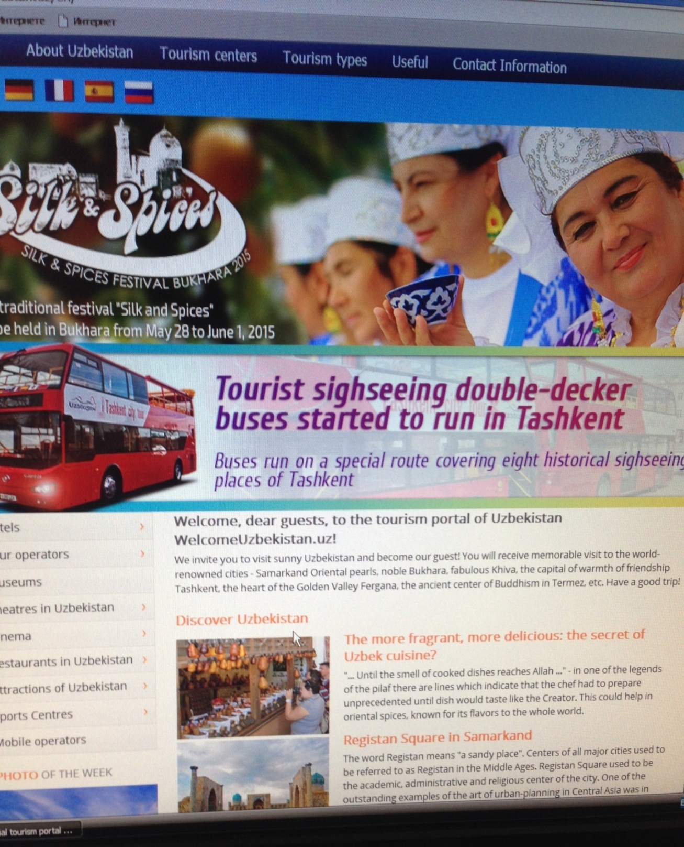

At first, we sit in front of computer and open Google.com and then we should write “official tourism portal of Uzbekistan” on SEM. After that SEM gives for us 295 000 results which participate on SEM

According to statistics 30% out of 100% internet user pass the 3rd page of the Google so that every company, enterprises and organizations apply their information databases on the 1st page of Internet

**Image 4.Appering“official tourism portal of Uzbekistan” on SEM**

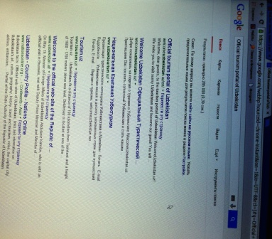

We can easily see official tourism portal of Uzbekistan (http://welcomeuzbekistan.uz ) is placed on the 1st step of the 1st page and then we open it a new page.**(открытьссылкувновойвкладке)**

**Image 5. Opening for a new page of “official tourism portal of Uzbekistan”**

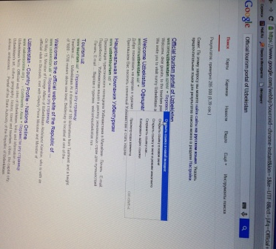

After waiting a little minute our new page is opened.We are admired by the design of the site. Site reflects to nationality and gives the latest new about Tourism sphere. E.g. The 21th Tashkent International “Tourism fair on the Silk Road” will take place the dates between October 6 and 8 in 2015.

The site uses very good on **Display advertising**

**Image 6.Web page of official tourism portal of Uzbekistan**

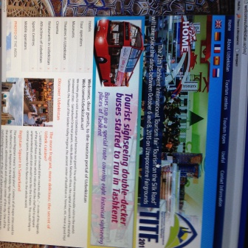

Let's do horizontal analyze the **6 units** of the site including;

1 Home

2 About Uzbekistan

3 Tourism centers

4 Tourism types

5 Useful

6 Contact Information

**Image 7.Making horizontal analyze 6 units**

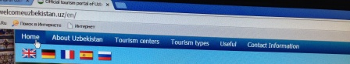

In order to examine all these 6 units are working well we enter **About Uzbekistan** part **General information about Uzbekistan .**The part gives precious information about geography territory, climate, natural features and public holidays of Uzbekistan.

**Image 8.About UzbekistanpartGeneral information about Uzbekistan**

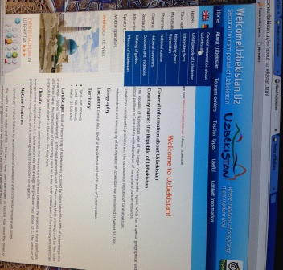

We enter the same unit for the next part namely, **Great people of Uzbekistan**.Unfortunately, the unit is written in The English language, but all the information in this part is composed in Russian language. This leads to one disadvantage of the site

**Image 9.Great people of Uzbekistan**.

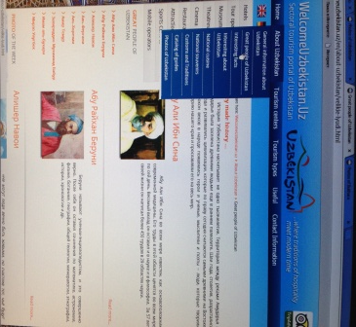

The part is **Catalog of guides** which illustrates only 6-8 guides all around Uzbekistan ,Besides, all information is written in the Russian language.

**In fact,** Uzbekistan Government acknowledges English language as a secondary language after its official language Uzbek.This part gives brief information about these guides such as phone number and e-mail

**Image 10.Catalog of guides**

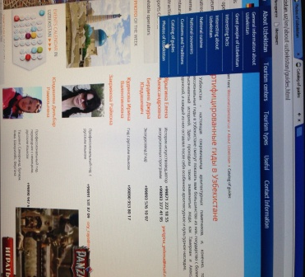

We examine another unit called “**Tourism centers”** choose from the 7 main touristic cities Bukhara (why Bukhara because I was born) While reading at information we can gain which information needs to us .I have recommendation to the part and I will give it on my SWOT analyze

**Image 11.Unit “Tourism centers” choose from the 7 main touristic cities Bukhara**

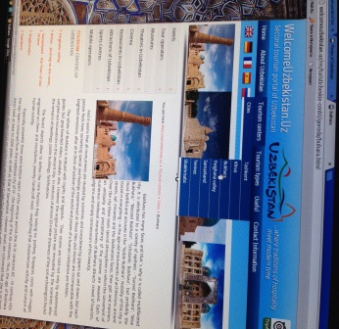

We continue examine another unit named **“Tourism types”** choose **Active tourism** illustrates**Rafting** - a fascinating walk down a mountain river in canoes or rafts special. **Caving**. Judging by the fact that cave explorers - people who in their spare time, go to the mountains with huge backpacks, it is tourism **Skiing and snowboarding** and so on

**Image 12. Unit “Tourism types” choose Active tourism**

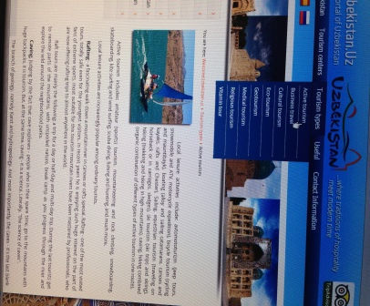

At the same unit but we enter another part called **Business travel.**In this part, we can see very little information about business travel. In order to engage in all tourists from all over the world. The site should include all the possibilities, uniqueness and features of business. Another disadvantage of the site and I will give the solution (recommendation) to the problem.

**Image 13.Business travel.**

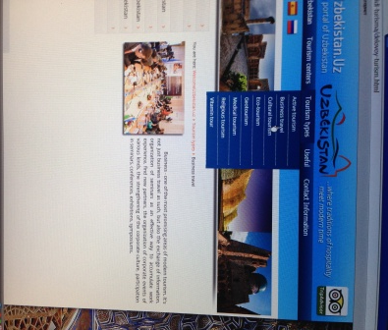

The same unit but another part called **“Medical tourism”** Unfortunately, the part is not worked this one of the biggest drawbacks of the site. **I** checked this part in a different time of the day but the part does not work

**Image 14. Part “Medical tourism”**

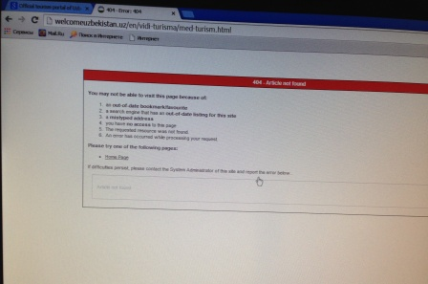

The other part is “**Vitamin tour”.** It is unique part that can helps to engage in tourists. The site includes  vegetables, fruits, herbs and spring water allows to diversify their diet and fully restore and replenish your body with vitamins stock available in abundance in Uzbekistan

By writing **“Vitamin tour”** at the part the site makes mistake. In fact, the definition of**tour** and **tourism** has very big differences. The definition of a tour is a trip or journey for sightseeing or for entertainers to perform in many cities. Tourism is the practice of traveling somewhere for fun.

**Image 15.Unit Tourism types part “Vitamin tour”**

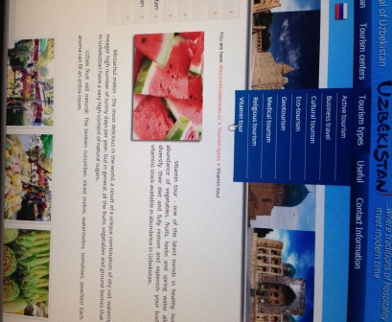

Let’s do vertical analyze the **9 unit** of the site including

**Image 16. Vertical units of Web site**

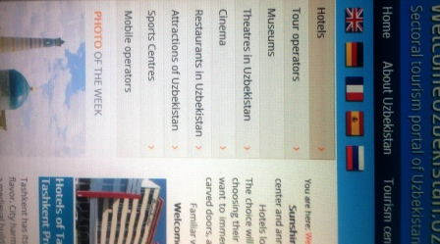

1. Hotels
2. Tour operators
3. Museums
4. Theatres in Uzbekistan
5. Cinema
6. Restaurants in Uzbekistan
7. Attractions of Uzbekistan
8. Sports centers
9. Mobile operators

We enter **Hotel**unit and we can easily see 12 province and each part illustrates with hotel e.g. we choose **Dedeman Silk Road** from the Tashkent province.This part tells us information about events, wedding, discounts , location faculties of the hotel Dedeman.In brief, this unit provide us all the information which we are interested. I mean that the part describes the hotels of 12 province with precious information.

**Image 17.Hotel unit choosingDedeman Silk Road**

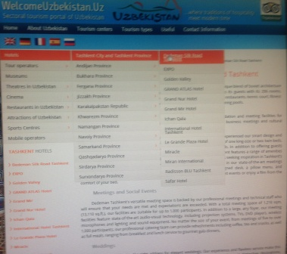

The following units –Tour operators , Museums,Theatres in Uzbekistan,Cinema Restaurants in Uzbekistan are available and working as a normal units except 1 or 2 disadvantages and I will write them for my **SWOT** analyzes

**Images 18-19. Appearing Museums and Cinema on the web site**

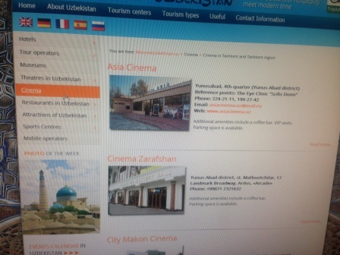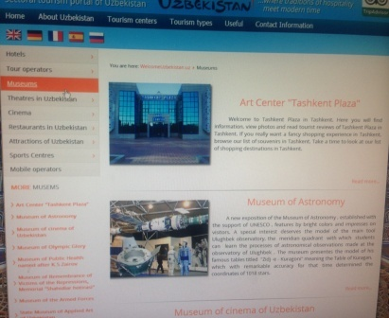

Unit attraction of Uzbekistan reflects all the sightseeing, historical places, monumental buildings all over Uzbekistan. It divides 12 part e.g. attraction of Bukhara, attraction of Tashkent and others

**Image 20.Unit attraction of Uzbekistan part Bukhara**

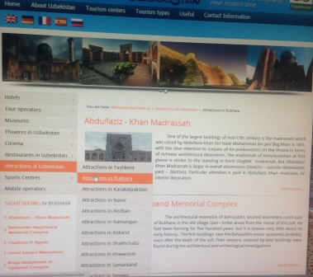

The unit of **mobile operators** gives information about special features of using mobile connections in Russian language.

**Image 21.The unit of mobile operators**

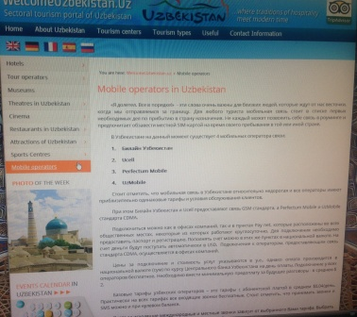

**Unit of Events calendar in Uzbekistan** illustrates some events which will be held in the honor of tourism in 2015 For example,14the traditional festival “Silk and spices” will be held in Bukhara from May 28 to June 1 2015.

**Images 22-23.Unit of Events calendar in Uzbekistan**

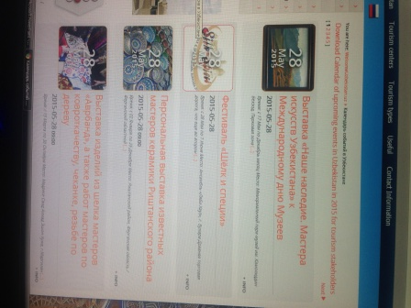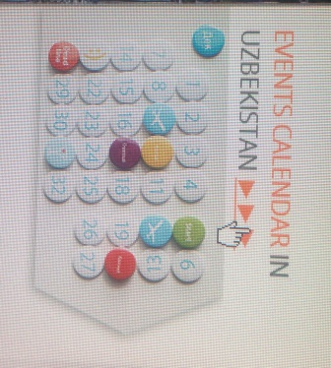

Timetable of flights and trains shows all the departure and arrival time on scheduled table

**Images 24-25 Timetable of flights**

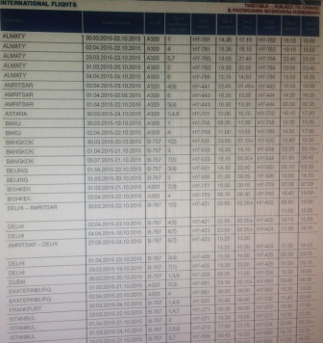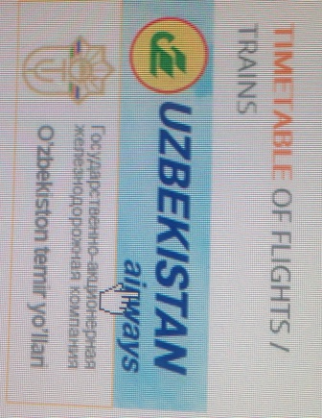

Unit of Weather in Uzbekistan forecasts 12 province of weather in coming 2 weeks. For instance, weather of Bukhara is displayed below timetable

**Images 26-27 Unit of Weather in Uzbekistan part Bukhara**

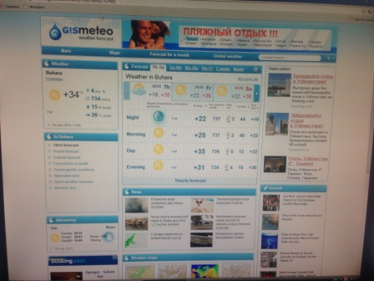

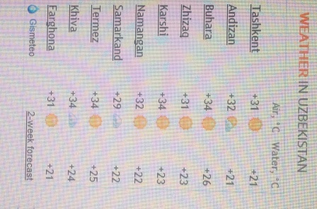

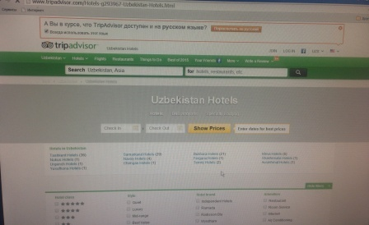If you click tripadvisor it will be opened

**Image 28-29Tripadvisor**

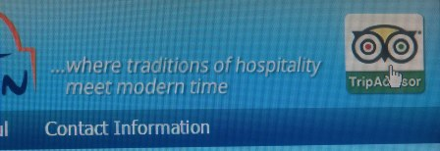

Using social marketing – Facebook, twitter, odnoklassniki and all viral marketing is working as a normal social media .

**Images 30-31.Using social marketing**

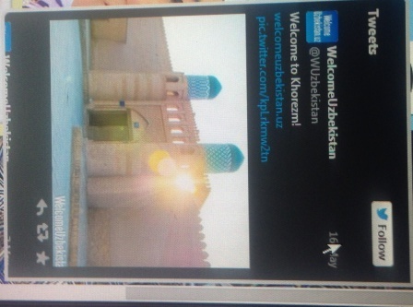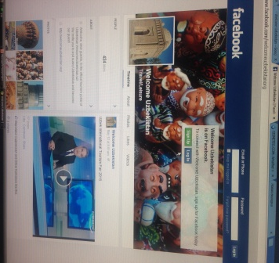

Units of links and useful information are working. In order to check we click Uzbekistan National News Agency ,

**Image 32.Units of links**

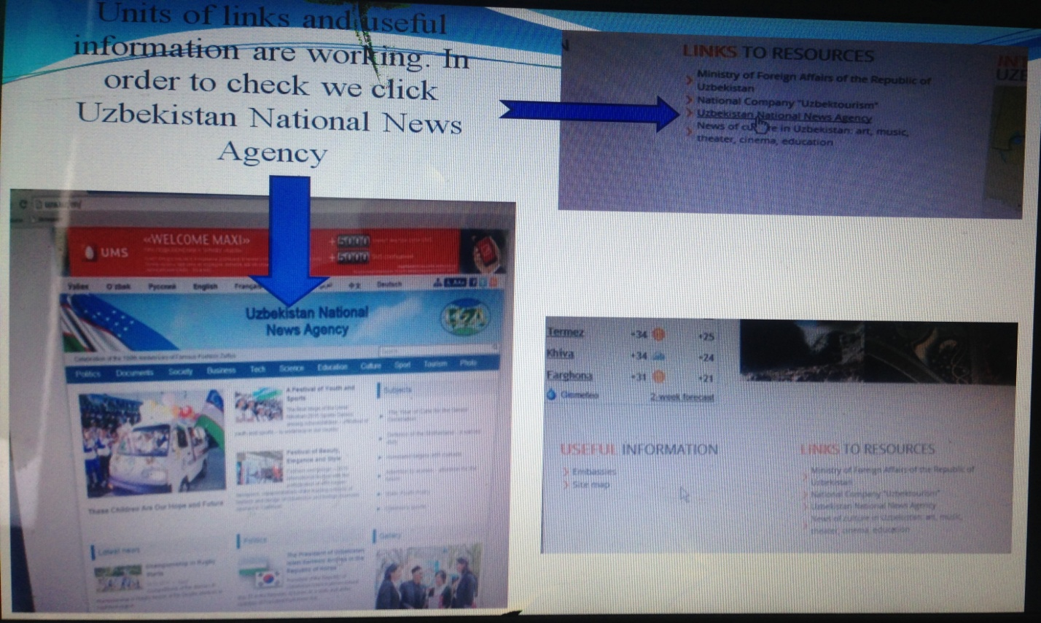

Unit multimedia shows all video rollick related to tourism service and sightseeing of Uzbekistan including Bukhara, Khiva, Samarqand and Tashkent

**Image 33.Unit Multimedia**

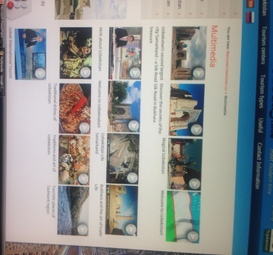

**3.3. Making SWOT analyzing official tourism portal of Uzbekistan**

**STRENGTHS of the official tourism portal of Uzbekistan**

1. The site can use from **Display advertising very** good !!!! Because of it, internet users will not be bothered and try to go on searching information via internet.

2. We are admired by the design of the site. Site reflects to nationality and gives the latest news about Tourism sphere. E.g. the 21th Tashkent International “Tourism fair on the Silk Road” will take place the dates between October 6 and 8 in 2015.

3. Events and festivals related to tourism sphere are shown as a poster. E.g.

14the traditional festival “Silk and spices” will be held in Bukhara from May 28 to June 1 2015.

4. We can easily use 5 main and major spoken languages from the site. Including,

English, Spain, French, Dutch and Russian.

5. The site uses very simple and understandable word to understand all of the clients, customer and internet users.

6. If someone choose sightseeing of Uzbekistan from unit attraction of Uzbekistan the part has been divided 12 province of Republic. E.g. attraction of Bukhara, attraction of Tashkent , attraction of Samarqand and others. That’s why users gain valuable information like where monumental buildings, historical places are located . Besides, after choosing any attraction of these places is shown on **Display advertising** with unique images.

7. The site reflects what types of tourism activities are available in Uzbekistan+.

8. Every unit has its own part. E.g. unit **hotels** part Bukhara hotels, Samarqand hotels, Tashkent hotels and others

9. Multimedia is available as a separate unit. It shows video rollicks of sightseeing , wonderful places , historical places of Uzbekistan.

10. The weather forecast of the 12 provinces is displayed on web page.

11. The site uses top social media marketing. Such as Odnoklassniki, Facebook,

Google plus, twitter and Vkontakte.

**WEAKNESS of the official tourism portal of Uzbekistan**

1. Even though both unit About Uzbekistan and **part** Great people of Uzbekistan are written in English language, but all the information of both of them is written in Russian language .
2. Unit About Uzbekistan part Catalog of illustrates only 6-8 guides .
3. Information of Unit Tourism types part Business travel is not clearly opened and the information is not enough to express for Business travel.
4. Unit Tourism types part Medical tourism is not totally work .
5. Unit Tourism types part Vitamin tour makes orthographical mistake.
6. Information of unit Cinema is written in Russian language .
7. Sport centers unit except Bowling part, the other parts namely, Paintball, Tennis clubs, Horse-ridding, Swimming pools and aqua parks do not work.
8. Information of Unit Event calendar in Uzbekistan is expressed in Russian language.

**Opportunities and THREATS of the official tourism portal of Uzbekistan**

* Appearing on the front page of SEM on 1st line.
* Reflecting upcoming events before 2 week in advance.
* Using very simple word to understand clients
* **THREATS**
* Competitors

**CONCULUSION and RECOMMENDATIONS**

Without online and mobile marketing, tourism and hotel businesses will miss out this growing consumer trend. This thesis investigates online and mobile marketing as a marketing channel used for promoting tourism and hotel products and services. An increasing number of tourist destinations use new technology and solutions to promote their tourism products and services.

This thesis defined the role of online marketing for promoting tourism products and services; it examines their advantages and disadvantages, the impact of online marketing on the tourism supply and demand, as well as the estimated future development of this channel. Furthermore, the paper analyzes mobile applications as a new tool to promoting and advertising tourism and hotel products and services. Since the amount of mobile devices constantly increasing, mobile applications can be a key point to sending immediate messages to consumers at the right time, in the right place. The findings in this paper may be useful in developing online and mobile marketing strategies in tourism and hospitality industry. Online marketing still has growth potential as technological development never stops and that will completely change the traditional and conventional types of advertising.

While all the tourism companies that were involved in this research use the Internet in some capacity there is a lot more that they can do. All the interviewees acknowledged the importance of the Internet and all showed considerable ambition to make their companies more visible online and to use the Internet in a more effective manner. The main reasons for not implementing these changes already is the lack of knowledge, time and funds. With the ever-increasing supply of tools for online developers it does not have to be complicated to develop and maintain a decent website.

Opening a website is of course not enough. The website and the business needs exposure and potential customers need to know that it exists. All those interviewed realize this and all have some way of exposing themselves online. At official tourism portal of Uzbekistan ,they have not used E-mail marketing, Affiliate marketing and Mobile marketing and social networks like Telegram in any real way. But we hope in the future they will use all of them to complicate official tourism portal of Uzbekistan.

Since most of the small businesses in this trade only have limited staff where the owners may be the backbone of the business and time is limited, it can only be beneficial to set aside a certain period of time to update the website and social network account frequently, answer emails and enquired within an acceptable amount of time, say 24 hours. Another big issue is the potential cost that comes with advertising and becoming more visible online. While this is of course a factor, the benefits can be a vast increase in visits and can therefore be very beneficial in the long run.

These examples show that hotel proprietors and others in the tourism industry should be really well informed about the Internet importance and most have certainly done something to make their businesses more visible online but they can still do a lot more.

* In a bid to increase their visibility on the Internet companies in the tourism trade have a number of options available to them. One such option is to increase the use of purchased advertisements of keywords on search engines like Google and Yahoo! This has been shown to benefit businesses greatly and can very well increase Uzbekistan visibility online.
* By having an active mailing list companies contact their former and would be clients in a fast and easy way with hardly any financial expenditure at all. Having some kind of special promotion to encourage people to sign up for the mailing list could be very beneficial and attract parties that may otherwise not have signed up for receiving the mail.
* By encouraging satisfied to write a review on websites like TripAdvisor, which has millions of active users, companies may very well get business that they otherwise would not have gotten. All the parties interviewed during the research mentioned that customers had mentioned that a favorable review on TripAdvisor had caused them to visit that location. An active profile on a social network like Telegram can bring attention to the establishment for the sites users that may otherwise never have known it existed.
* E-marketing is an important‘ communication channel' between offer and demand in modern tourism. With the help of E-marketing , there is an opportunity for all operators in tourism industry to successfully promote and sell services and products and to act in accordance with desires and needs of modern consumers.
* To sum up, even though the site official tourism portal of Uzbekistan has some drawbacks, but the site can totally use from Display marketing, Social media marketing Viral marketing and Blok marketing. It would be very nice If the site is fulfilled from E-mail marketing, Affiliate marketing and Mobile marketing
* In order to prevent disadvantages of the site I will give the following recommendations , from my personal prospective .

**RECOMMENDATIONS**

* Information of the site should be translated in English language.. In fact, English the second most spoken language as well as the most international one in the world.
* Catalog of guides should be illustrated not only 6-8 guides service but also a lot of them.
* Some parts like Business travel ought to be completed with special features of business travel and be supplied with precious infor0mation in order to engage in tourists from all over the global.
* Part Medical tourism should be reconstructed to work as a normal part of the site.
* Some of orthographical mistakes should be corrected. Because between word definition of tour and tourism has a big difference. The definition of a tour is a trip or journey for sightseeing or for entertainers to perform in many cities, while Tourism is the practice of traveling somewhere for fun.
* Parts namely, Paintball, Tennis clubs, Horse-riding, Swimming pools and aqua parks should be corrected and Site should use pictograms

Adding video rollicks while giving the information about attraction of Uzbekistan. According to research, character of human being is likely to more watch rather than reading a whole story or information .E.g. We decide to go Bukhara and we choose unit Tourism centers part Bukhara at this part should be video rollicks in order to attract newcomers . This leads to use **Social media marketing** or viral marketing and **Display marketing**

* The site should create another unit called **Travel tips** because newcomers will be informed valuable information about the weather, locations and he or she knows what kinds of clothes wear before coming the destination. Source- Visit bulgaria and Visitturkey official tourism portals.
* Using Mobile marketing –www.jeffbullas.com
* Over 1/3 of Facebook’s users access Facebook Mobile; 50% of Twitter’s users use Twitter Mobile
* There are currently **6 Billion** mobile subscribers worldwide. This equals **87%** of the world’s population.
* There are over **1.2 Billion**people accessing the web from their mobiles
* Creating unit **Don’t miss …** In this part we can add interesting information with unique and irreplaceable video rollicks of attractions which is interesting to user internets .
* Creating unit **Leave your comment…** this part helps to tell disadvantages and advantages of the site by putting comments on the web.

Using pictograms to be understandable for everybody

**Image 34.Using via pictograms**

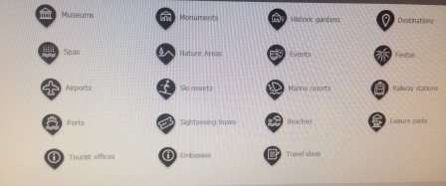

Adding more languages **Image 35.Language**

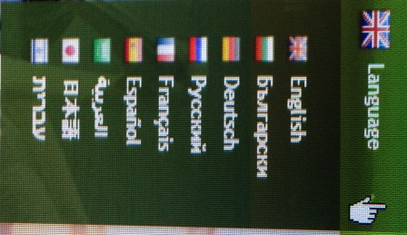

Creating unit **Sound** the music should be national music which reflects hospitality, traditions and customs of Uzbek peoples. It helps to not to get bother users of website of Uzbekistan.

Creating unit Text version .It helps to give information within a few minute.

**Image 36.Creating unit Sound and Text version**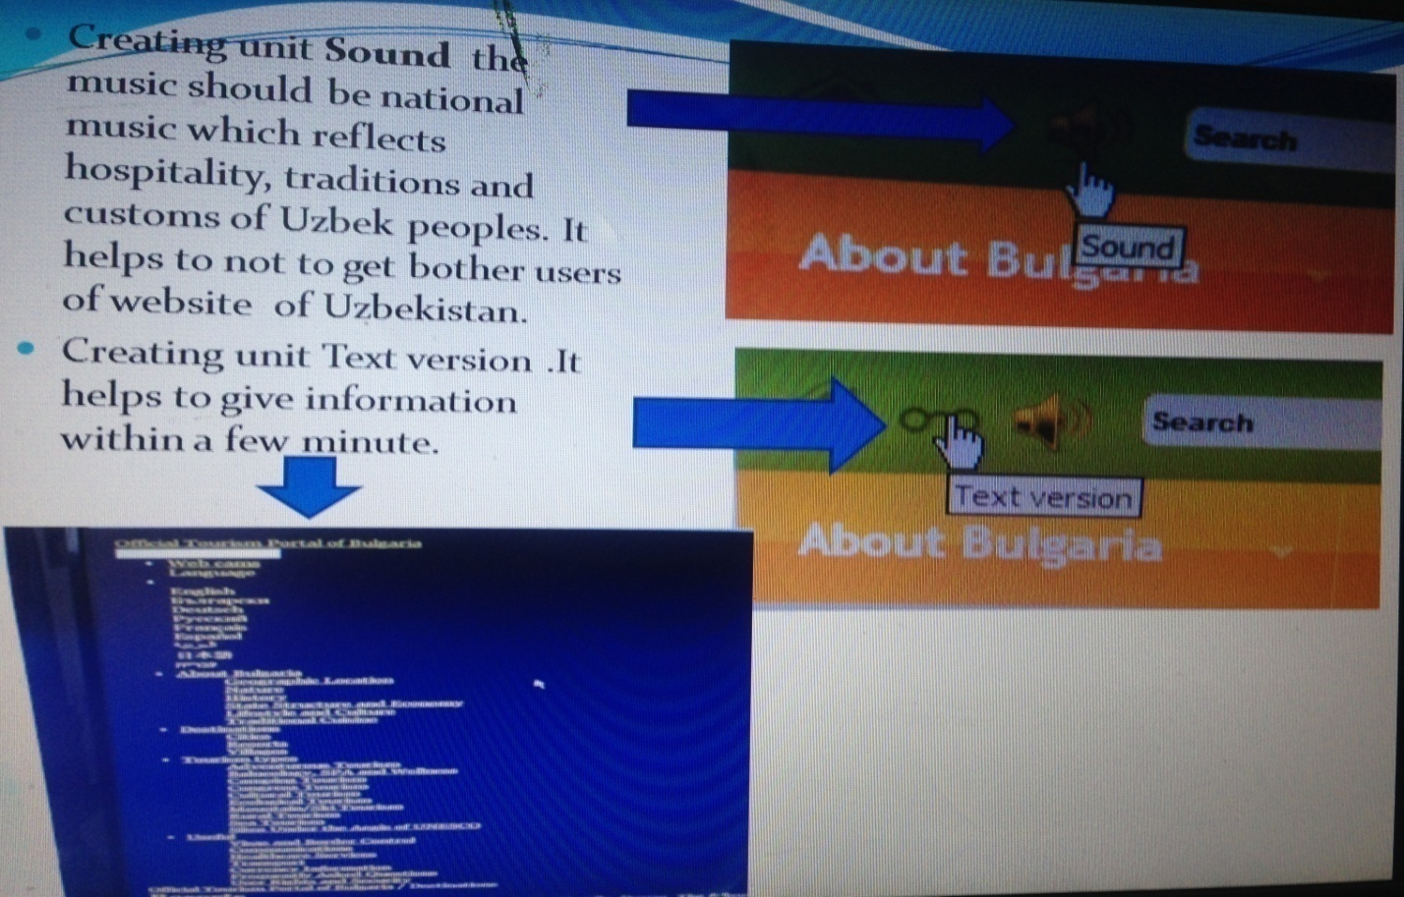

Avoiding some orthographic mistakes and developing Vitamin tourism and illustrate with information and applying video rollicks. According to statistics in Prague festival of vegetables and vitamins especially melon and watermelons are celebrated twice a year

Image 37-38. Festival of vegetables and vitamins



**ANNOTATSIYA**

**Mavzu: Mehmonxona biznesida elektron marketingning imkoniyatlaridan foydalanishning o’ziga xos xususiyatlari.**

**Theme: Special features of using E-marketing in the field of hotel industry.**

**Mavzuning dolzarbligi.** Prezident I. A. Karimov O'zbekiston Respublikasi Oliy Majlisi Qonunchilik palatasi va Senatining qo'shma majlisidagi ma'ruzasida ham ushbu masalalarga katta e'tibor berdi:

Mamlakatimiz iqtisodiy taraqqiyotining eng muhim istiqbollari va ustuvor yo'nalishlarini belgilab olar ekanmiz, biz ichki ehtiyojning o'sishiga alohida e'tibor qaratishimiz kerak bo'ladi. Jahon moliyaviy - iqtisodiy inqirozi oqibatlarini yumshatishga qaratilgan inqirozga qarshi choralar dasturida ana shunday yondoshuv asosida ish tutganimiz o'tgan yillarda o'zini to'la oqladi. Ta'kidlash kerakki, bugungi kunda Osiyodagi ko'plab mamlakatlar aynan shunday pozistiyaga amal qilib kelmoqda.Shundan kelib chiqqan holda, bizning yaqin istiqboldagi eng muhim vazifamiz boshlagan ishlarimizni izchil davom ettirish - iste'mol talabini kengaytirish maqsadida sostial sohani rivojlantirish, mehnatga haq to'lashni yanada oshirish, xizmat ko'rsatish sektorini, infratuzilma ob'ektlarini rivojlantirishga, transport va kommunikastiya loyihalari amalga oshirilishiga alohida e'tibor berishdir" .

Internet rivojlanishi bilan birga nafaqat turistik biznesda qatnashuvchilarning joyi va roli, ular o`rtasidagi munosabatlar balki xo`jalik yuritishining butun falsafasi-turistik marketing qayta ko`rib chiqilmoqda. Umumjahon informatsion tizimi ana`naviy marketing usullarini samarasiz qilib qo`ymoqda. Xizmat ko`rsatish soqasida ishlovchi marketologlar yangi elektron aloqa vositalari imkoniyatlaridan to`la qonli foydalanishni istasalar tarmoqning bu xususiyatlarini hisobga olishi zarur. Shunday zamonlar bo`lganki, odamlar kompyuterlar bir necha yillar davomida qilinadigan ish hajmini soniyalar davomida bajarishini, fan va texnologiyalar hozirgi kunlarda qo`llanilayotgan qamrovlarda tadbiq etilishi haqida tasavvur ham qila olishmagan. Ellik yil oldin eng rivojlangan mamlakatlarda kapital qo`yilmalar yiliga 3%dan ortiq o`smagan, lekin fan sohasidagi tadqiqotlarga qo`yilmalar yiliga 6-15 %ga o`sgan.

**Bitiruv malakaviy ishining maqsadi-**Mehmonxona biznesida elektron marketingning imkoniyatlaridan foydalanishning o’ziga xos xususiyatlarini o'rganish,O'zbekistonning rasmiy turistik portalini tahlil qilish va tavsiyalar berish

**Bitiruv malakaviy ishining vazifalari**.

Qo’yilgan maqsadga erishish quyidagi vazifalar yechimi bilan bog`liq:

- Turizmda onlayn va mobil marketing haqida tushuncha.

- Elektron turizm soxasida veb saytning roli.

- Turistik saytlar va ularning tavsiloti.

- Turistik saytlar sifatini baholashda modellardan foydalanish.

- O'zbekistonning rasmiy turistik portalini tahlil qilish va tavsiyalar berish

**Bitiruv malakaviy ishi**  kirish, 3 ta bob, xulosa va takliflar va foydalanilgan adabiyotlar ro'yxatidan iborat.

**1-bob**da Elektron marketingning turizm va mehmonxona sanoatida tutgan o'rni va ustunliklari ochib berilgan. Unda elektron marketingning tasnifi, tarixi, usullari, turistik korxonalar uchun manfaatli tomonlari, zamonaviy turizm va sayohat kompaniyalari uchun qulayliklar batafsil bayon qilingan.

**2-bob**da elektron marketingning turizm sohasiga qo'shgan hissasi va mobil marketing tushunchasi, tasnifi, ijtimoiy tarmoqlar orqali rivojlantirish ijtimoiy tarmoqlar tushunchasi, mohiyati, turizm sohasida mobil marketing vositalarini qo'llash imkoniyatlari ochib berilgan.

**3-bob**da O'zbekistonda online marketingning rivojlanishi va mohiyati deb nomlanadi unda O'zbekistonning rasmiy turistik portalini tahlili misol qilib olingan, Swot tahlil qilingan, hamda saytning kamchiliklarini o'rganish.

Xulosa qismida esa olingan bilim va ko'nikmalardan foydalangan holda O'zbekistonning rasmiy turistik portalida qo'yilgan kamchiliklarni oldini olish va yanada saytni jozibador va murakkabroq ko'rinishda keltirishni faktlar asosida tavsiyalar berish.

Turizm iqtisodiyotiga kompyuter texnologiyalari katta foyda keltira boshlagan tarmoqlaridan biriga aylanib qoldi. Bularga aviachiptalar, boshqa turdagi transport vositalari uchun chiptalar, sayohatlar va meqmonxolarda xonalar uchun avvaldan buyurtma berib qo`yish tizimlari kiradi. Bugungi kunda Amadens, Gabriel, Sabre, World Spar, Apollo va boshqalar kabi eng yirik tizimlarning O`zbekistonda o`z vakolatxonalari ochilgan. Bundan tashqari Internet - jahon axborot tarmog’ining ahamiyati bu sohada kun sayin ortib bormoqda. lnternet-texnologiyalar turistik firmalarga xalqaro telefon suhbatlari va faks yo`llash uchun xarajatlarni qisqartirish evaziga katta miqdordagi mablag’larni tejashda yaqindan yordam beradi. Yil sayin aviachiptalar va meqmonxonalarga avvaldan buyurtma berish tizimidan foydalanayotgan turistik firmalarining soni ortib bormoqda. Bunday tizimlar jahonning barcha mehmonxonalarida xonaga buyurtma berish qisqa vaqt davomida ish joyini tark etmagan holda buyurtma berish shartlari, narxlar, imtiyozlar to`g’risida ma`lumot olish imkoniyatini beradi. Avvallari bu ishlarni amalga oshirish uchun uzoq vaqt va mablag’ kerak bo`lardi. Tizimga kiruvchi agentliklar hozirgi kunda o`tgan yilgi ma`lumotnomalardan emas, balki eng oxirgi ma`lumotlardan foydalanishadi.

Internetda u yoki bu turistik mahsulot haqidagi video, rasmlarni tomosha qilishingiz va bu mahsulotlar to’grisida boshqalar qoldirgan fikrlarni o’qishingiz mumkin. Siz o’z dam olishingizni modellashtirasiz, o’zizga moslab olasiz. Turagentliklar turli reklama va qiziqtiruvchi takliflarga boy. Elektron turizm-bu faqatgina pul tejashning ajoyib yo’li bo’libgina emas, balki qimmatli vaqt va asablaringizni ham asrashga yordam beruvchi usuldir.

Xo'sh shunday ekan **elektron marketing** o’zi nima ?

E-marketing bu -internet marketing, web marketing, online marketing yoki digital marketing deb ham ataladi. Bu mehmonxonda industriyasida va buzinessda juda katta rol o’ynab kelmoqda. Hozirgi kunda e-marketing oddiy marketingdan ko’ra ancha ko’proq miqdorda yoki hajmda daromad keltirmoqda.

E-marketingning metodlariga quyidagilar kiradi:

1. **Search engine marketing 1.Qidiruv(izlash ) marketing**
2. **Display Advertising 2.Reklama marketing**
3. **E-mail marketing 3. E-mail marketing**
4. **Blog marketing 4. Blog marketing**
5. **Social media marketing 5.Ijtimoiy ommaviy axborot marketing**
6. **Mobile marketing 6. Mobil marketing**
7. **Affiliate Marketing. 7. Tarmoqli marketing**

Ularning har biri haqida bir oz bo’lsaham to’xtalib o’tamiz chunki biror tadqiqot olib borish uchun dastavval o’sha mavzuga oid ma’lumotlarning nazariy qismiga o’xtalib o’tish kerak.

**Search engine marketing bu** - Google.com da yoki Yahoo da ma’lumotlar qiduruvda birilganda qidiruv natijalarni chiqaradigan ma’lumotlar ba’zasi hisoblandi. Boshqacha qilib aytganda, biror bir ma’lumotni Google.com qidiruvda berishga ko’rinadigan internetning birinchi beti (yuzi ).

Image 39. **Search engine marketing**



**Display marketing bu-** Marketingning bir turi bo’lib, websaytning old yuqori, old quyi.old o’ng ,old chap paski qismlarda bo'lishi mumkin. Bu marketing ba’zan

Display advertisingdeb ham ataladi .Bu turli xilformat ko’rinishlarida bolishi mumkin va u o’z ichiga video, audio teks va rasmlarni o’z ichiga oladi.Display marketingning eng asosiy vazifasi bu –umumiy reklamalarni va braendga bog’liq bo’lgan xabarlarni yetkazish (ko’rsatish )

Image 40. Display advertising

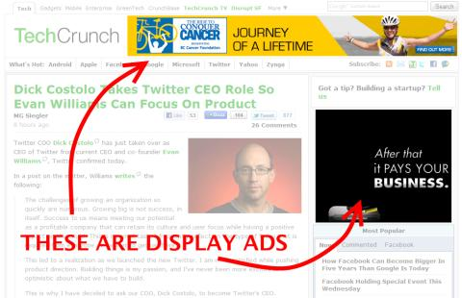

**E-mail marketing bu-** to’gridan to’g’ri marketing turi bo’lib, biznessga aloqador bo’lgan malomotlarni elektron pochta orqali bir guruh insonlarga yuborish.Masalan, siz bir korxona raxbari bo’lib, oz’ maxsulotlaringizni sotish uchun emaildan foydalanib o’z tovarlaringiz electron pochta orqali savdo qilishga aytiladi.

**Blog marketing bu-**alohida bir mavzu bo’yicha blog yoki veb sahifalar orqali marketingni amalga oshirishdir

**Image 41.Blog marketing**

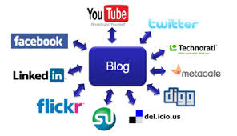

**Social media marketing bu –** hammaga ma’lum bo’lgan ommaviy axborot vosistalardan foydalanish .Misol uchun Facebook, Vkontakte, Odnoklassniki, Twitter va boshqalar kiradi.Ba’zan bu **Viral marketing** deb ham ataladi.

Image 42.**Social media marketing**

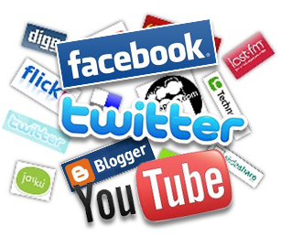

**Mobile marketing bu –**simsiz telefonlar yoki telefon turiga kiradigan uskunalar ya’ni planshed ,ipad, mini planshedlar orqali o’z maxsulotlarni sotish yoki sotib olishga mobile marketing deyiladi.Mobile marketingning bir necha xil turlari bo’lib ular quyidagilar:

Figure 2.Types of mobile marketing

**SMS (short message service):** Bu qisqa xabar xizmati bo’lib, reklamachilar marketinga aloqador bo’lgan xatlarni sms orqali yuvorish.

**MMS(multi-media message service):**Bu ko’p sonli xabarlar xizmati bo’lib, o’z ichiga rasmlar,videolar va audiolarni xizmatlarini yuvorishni o/z ichiga oladi.

**Mobile Applications:**Bu applardan xaridorlar bilan munosabat o’rnatish juda oson hisoblandi .Bu assosan Iphone yoki smartphone kabi telefonlardamavjud bo’ladi.

**Bluetooth Proximity:**

**Location-Based Marketing:** Bu axborotlarni GPS xizmatlariga bog’liq bo’lgan holda foydalanuvchining telefoniga to’gridan to’gri axborotlarni yuborish.

**QR Codes(quick-response barcodes):**Bu xaridorlarga mahsulot haqida tezroqo’rganish imkonini beradi . Ular telefon versiasi orqali mahsulotlarni tekshirib olishadi.

**Mobile Banner Ads:** Buweb saytdagi oddiy bannerga o’xshaydi biroq hajmi chihatidan biroz kichikroq chunki faqat telefon orqali foydalanish uchun mo’ljallangan .

**Mobile Web:** web saytning mobile varianti bo'lib hozirgi kunda undan foydalanuvchilar soni ko'pyib o'zlaring telefonlari orqali ma'lumotlarni qidiruvga berishadi.

**PPC (Pay Per Call) Mobile Marketing:** Odatda reklama e’lonlari xaridordan ma’lum bir topshiriqni bajarishni so’raydi. Masalan e’londa berilgan raqamga tel qilish kabi.

**Affiliate marketing** Tarmoq marketingi bu-faoliyatga assoslangan marketing turi bo'lib, bunda biznessdagi yutuqlar bir yoki ikki hamkorning har bir tashrif buyuruvchi yoki xaridor uchun amalga oshirgan shaxsiy marketing faoliyatini uyg'unlashtirish eaziga bo'ladi.

Har bir narsaning ikki tomoni bo'lib bizOnline marketingning kamchiliklari va yutuqlariga biroz to'xtalib o'tamiz.

**Kamchiliklari**

**Internet tezligining pas bo'lishi.**Agar biror bir kompaniyalar websaytlarini juda ham murakkab va juda katta hajmda yaratsa, bu websaytdan foydalanuvchi uchun undan foydalanish yoki kerakli ma'lumotlarni yuklab olish uchun ko'p vaqt ketadi va natijada saytan foydalanuvchila zerikib qoladi.

**Yana bitta omil bu to'lov.**Hozirgi kunda ham ko'plab internet foydalanuvchilar elektronic uslubda to'lashda ishonishmaydi va natijada ular bu usulda to'lashdan voz kechadi.

**Tovlamachilikning bo'lishi.**Xaridor biror bir xizmatga yoki buyumga pul to'lagandan keyin o'sha xizmat yoki buyumning o'z xaridoriga yetkazmaslik.

**Yutuqlari**

**Ma'lumotlarning juda tez almashinuvi-**Xaridorlar o'ziga tegishli bo'lgan ma'lumotlarni internetga qidiruv berish orqali o'zlaring mahsulotlari va qaysi mahsulotlarni oldindan buyurtma qilish kerakligi haqidagi ma'lumotlarni kunning xoxlagan paytida tekshira oladi

**Raqobatni keltirib chiqaradi.** Mahsulot ishlab chiqarish borasidagi katta va kichik korxonalar bir biriga nisbatan raqobatchi boladi, bu esa xaridor uchun qulay salanadi.

**Jahon bozoriga chiqishi .**Kompaniyalarning elektron marketingdan foydalanishi mahaliy va ichki bozordan jahon bozoriga bir vaqtning o'zida chiqishi va cheksiz imkoniyatlarning kengayishini beradi.

**Internetda hamma narsa inobatga olinishi** ya'ni kompaniya faoliyat olib boryaptimi yoqmi va qaysi turdagi mahsulotga xaridor ko'proq talab ko'proq bular hammasi internet orqali yuzaga keladi.

**Mablag'ni tejash** ya'ni bunda companiyalar reklama uchun ortiqcha pul to'lashmaydi.Tezlik ya'ni bunda siz minimum vaqt sarflaysiz natijalarni qo'lga kirish uchun.

Bitiruv malakaviy ishning amaliy qismiga o'tamiz va biz bunda yuqorida olgan bilim va ko'nikmalardan foydalangan holda O'zbekistonning rasmiy turistik web portalini(http://welcomeuzbekistan.uz) tahlil qilamiz. Bunda web saytning yutuqlari kamchiliklari ba'zi xatolari haqida to'xtalib o'tamiz.

Dastaavval biz kopyuter olda o'tirib,Google.com ga kiramiz va SEMda biz **"**O'zbekistonning rasmiy turistik web portali" deb qidiruvga beramiz. Birozdan so'ng yuqorida qatnashgan so'z 295 000 natijalar chiqadi. Statistik ma'lumotlarga ko'ra, internetdan ya'ni Googledan foydalanuvhilarning 100% dan 30% gina googlening 3-betiga o'tar ekan. Shuning uchun hamma korxonalar , tashkilotlar, turistik tuor agenlar o'zlaring ma'lumotlar ba'zasini googlening 1-betiga qo'yishni orzu qilar ekan.

Keyin biz **"**O'zbekistonning rasmiy turistik web portali"ning 1-betining 1-o'rnida turganini ko'ramiz va biz bu web saytni yangi alohida bet sifatida ochamiz ya'ni biroz o'tgandan so'ng yangi sahifa ochiladi.

Ochilgan web sahifaning dizayni ko'zni maftun qiladi.Web sayt milliylikni o'zbeklarning urf-odatiga mos uyg'unlikni aks ettirgan va turizm sohasiga taluqli bo'lgan eng so'ngi yangliklardan xabardor qilyatganligi.Masalan- "Ipak yo'lidagi turizm" deb nomlanuvchi Toshkent xalqaro turizm yarmarkasining 21 yillik yubileyi munosabati bilan 2015-yil 6-8 oktabr oyida o'tkazilishi kutilayotgan yangilik misol bo'ladi.Shunday qilib sayt Display advertisingdan yaxshi foydalana olgan.

Web saytni gorizontal analiz qilishni boshlaymiz.U quyidagilarni o'z ichiga oladi.

**1 Home**

**2 About Uzbekistan**

**3 Tourism centers**

**4 Tourism types**

**5 Useful**

**6 Contact Information**

Bu bo'limchalarning har birini ishlayotganligini yoki ishlamayotganligini tekshirib ko'ramiz.**About Uzbekistan**bo'limining **General information about Uzbekistan**qismga kiramiz.Bu qism bizlaga O'zbekiston haqida umimiy ma'lumotlarni beradi. Masalan' uning geografik o'rni , iqlimi tabiati va milliy bayramlari haqidagi ma'lumotlarni beradi. Biz shu bo'limning **Great people of Uzbekistan**deb nomlangan qismiga kiramiz. Baxtga qarshi bo'lim ingliz tilida yozilgan bo'lsa ham lekin ichidagi ma'lumotlar rus tilida berilgan bu esa web sahifaning kamchiligi sanaladi.

**Catalog of guides** deb nomlangan qism butun O'zbekiston bo'ylab faqatgina 8 ta gidning xizmatidan foydalanish mumkin ekanligi va ulardagi ma'lumotlarning rus tilida yozilganligining guvohi bo'lamiz.

Xulosa qilib aytaydigan garchi **"**O'zbekistonning rasmiy turistik” web portal ba’za kamchiliklari bo’lishiga qaramay web sahifa Display marketing, Social media marketing Viral marketing va Blok marketinglarda oqilona foydalana olgan va bukamchiliklarningoldiniolishmumkinliginibilganholdao'zbilimvamalakamgaasoslanganholdaquyidagitasiyalarniberaman.

* Web sahofadagi ma’lumotlar rus tilidan ingliz tilida qilinishi kerak chunki ingliz tili dunyo tillaring eng ko’p foydalaniladigan til sifatida tan olingan
* **Catalog of guides**deb nomlanuvchi bo’limda O’zbekistonda faoliyat olib borayotgan gid xizmatlarini to’liq ma’lumotlar bilan ingliz tilida to’ldirish
* Ba’zi qismlar masalan **Business travel**deb nomlanuvchi sayt qismlarni turistlarni jalb qilish uchun shu sohaga tegishli bo’lgan ma’lumotlar bilan boyitib web sahifadan foydalanuvchilar qiziqtira bilish lozim.
* **Part Medical tourism** deb nomlanuvchi qism saytda ummuman ishlamaydi bu esa o’z navbatida web sahifaning kamchiliklaridan biri bo’lib bu sohani rivojlantirish va shu qismni qayta takomillashtirish kerak bo’ladi.
* Web sahifada orfagrafik xatolar ham uchurab turadi. Masalan saytda Vitamin tour deb yozilgan vaholanki bu Vitamin turizm bo’lishi lozim. Tour va tourism so’zlarning tarifi boshqa ma’nolarni bildiradi.Bundan tashqari shu sohani rivojlantirish uchun turli xil festival yoki tadbir va marosimlar o’tkazilsa maqsadga muvofiq bo’ladi. Ma’lumotlarga ko’ra Chexiyaning Proga shahrida har yili bir marotaba Tarvuz festivali o’tkazilib keladi va bu Chexiyada tashrif bururuvchi turistlarning kamida 10%-30%gacha turistlari bu festivalda qatnashadi

Images 43-44 Festival of Prague



* Destinatsiya yoki diqqatga sazovor joylarga tegishli bo’lgan video roliklardan foydalanish. Agar turist Buxoro haqida tasavvurga ega bo’lishi Buxoroga tegishli bo’lgan qiziqarli video rollick qoyilsa maqsadga muvofiq bo’ladi. Psixologlarning aytishicha insonlar kundan kunga dangasa va ishyoqmasa bo’lib boraveradi.Bundan kelib chiqadiki turist butun Buxoro haqidagi ma\lumotlarni o’qib turmay shu video rolikka kirib Buxoro haqida tegishli tushuncha hosil qiladi.Masalan, Buxoro haqida euro newsning quyidagi roliklani qoysa bo’ladi. **https:/www.youtobe.com/watch?v=QlySH3PfADc** ingliz tilida berilgnan ma’lumotlar **https:/www.youtobe.com/watch?v=toas--4_ttl** rus tilida berilgan ma’lumotlar
* Piktogrammalardan foydalanish kerak

Image 45 using pictograms

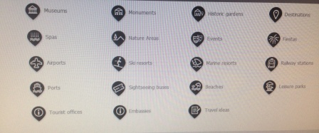

* **Travel tips,Don’t miss … va Leave your comment…**deb nomlanuvchi bo’limlarni qoysa shuncha yaxshi. Bunda turistlar biror bir joyga borishga qaror qilsa unda qanday kinish kerakligi, nimalar olib yurilsa yxshi ekanligi va shunga o’xshash bo’lgan ma’lumotlarni **Travel tips**dagi ma’lumotlardan oladi.
* **Don’t miss…**  deb nomlanuvchi bo’limda biror bir qiziq festival bayram yoki video rolliklarni qoysa bo’ladi.
* **Leave your comment…**da esa bunda **"**O'zbekistonning rasmiy turistik “web portalidan foydalanuvchilar web portalning kamchiliklari, yutuqlari va tavsiyalar qoldirib web sahifaning yanada mukammalashiga hissa qo’shadi
* **Mobil marketing**dan foydalanish yoki **Mobile Web** dan foydalanishni yo’lga qilish. Statistik ma’lumotlarga hozirgi kunda dunyo aholisining 6 mlrd ya’ni 87%da internet bor bo’lgan telefondan foydalanadi.DUnyo bo’ylab 1.2 mlrd aholi telefonlari orqali Web sahifalardan foydalanishgan**(www.jeffbullas.com)**
* **"**O'zbekistonning rasmiy turistik “web portalida touvushli yoki musiqali **(Sound)** qism bo’lsa maqsadga muvofiq bo’ladi.Chunki bunda musiqalar milliy mitalitet va an’analarni aks ettirishga. Undan tashqari sahifadan foydalanuvchilarni zerikrib qoymaydi

Image 46 Creating Sound unit



* Web sahifadaning teks versiyasidan**(Text version)** foydalanish bunda saytdan foydalanuvchi qidirayotgan ma’lumotlarni bir necha soniyda qo’lga kiritishga yordam beradi.
* Image 47. Creating Text version

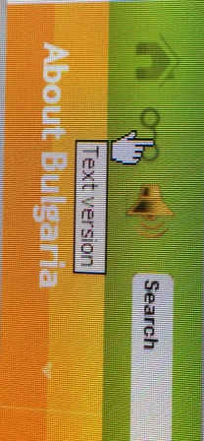

* Web sahifani Appstore dan foydalanishni yo’lga qoyish lozim.

**REFERENCES**

1. “Turizm to’g’risida” O’zbekiston Respublikasining qonuni. O’zbekistonning yangi qonunlari.-T.:”Adolat”,2000
2. Karimov I.A. Barcha reja va dasturlarimiz vatanimiz taraqiyotini yuksaltirish, xalimiz farovonligini oshirishga xizmat qiladi. T: O’zbekiston, 2013.
3. Karimov I.A. Jahon moliyaviy-iqtisodiy inqirozi, O’zbekiston sharoitida uni bartaraf etishning yo’llari va choralari.T.:O’zbekiston, 2009.
4. Shodmonov Sh.Sh., Yusupov R.A. Zamonaviy bozor iqtisodiyoti nazariyasi va amaliyoti. – T.: TDIU, 2007.
5. Александрова А.Ю.Международный туризм(учебник)-М.:Аспект Пресс, 2002.-470 с.
6. Балашова Е. Гостиничный бизнес(Как достичь безупречного сервиса)-М.:ООО «Вершина», 2005. -176 с.

Биржаков М.Б. Введение в туризм: Учебник. – Издание 7-е, – СПб.: «Невский фонд» - «Издательский дом Герда», -М.: 2004. - 448 с.

1. Менеджмент туризма: Учебник для студентов / Авт. Сост. И.В.Зорин. -М.: РМАТ. 1996 – 59 С.
2. Моисеева Н.К. Стратегическое управление туристской фирмой. -М.: «Финансы и статистика», 2001.-208 с.
3. Папирян Г.А.Международные экономические отношения:Маркетинг в туризме-М.:«Финансы и статистика», 2001.-160 с.

Русско-узбекский словарь/ Ред. коллегия: Кошчанов М.К. и др. II том, -Т.: Главная редакция Узбекской Советской Энциклопедии, 1983.

Наруззода Б.Н. Регионально-маркетинговый подход к управлению туризмом. – Вестник Бишкекского государственного университета экономики и предпринимательства, №2, 2006, С. 22-25.

1. Matthew Buckland, “The Future of Social Networking—A Concept Investigation with Augmented Reality,” matthewbuckland.com, October 1, 2009, [http://www.matthewbuckland.com/ ?p=1041](http://www.matthewbuckland.com/?p=1041)(accessed June 24, 2010).
2. “Clickatell: Get Instant Cover before Travelling; Metropolitan Life and Clickatell Introduce the World’s First Insurance by Mobile Phone in South Africa,” InsuranceNewsNet, May 8, 2006,<http://insurancenewsnet.com/article.asp?n=1&neID=200705083600.3_70ed00196de34624> (accessed November 14, 2008).
3. Kim Dushinski, “Text-to-Donate Alive and Well in U.S.,” Mobile Marketing Watch, July 18, 2008, <http://www.mobilemarketingwatch.com/text-to-donate-alive-and-well-in-us-1107> (accessed June 24, 2010).
4. Katie Fehrenbacher, “10 Things to Know About Short Codes,” GigaOM, March 16, 2007, <http://gigaom.com/2007/03/16/10-things-to-know-about-short-codes> (accessed November 14, 2008).
5. Jonathan Fildes, “Texts Tackle HIV in South Africa,” *BBC News*, October 24, 2008, <http://news.bbc.co.uk/2/hi/technology/7688268.stm> (accessed November 14, 2008).
6. Internet World Stats, [http://www.Internetworldstats.com](http://www.internetworldstats.com/) (accessed December 17, 2009).
7. “Introduction to Mobile Search,” Mobile Marketing Association, August 2008, <http://www.mmaglobal.com/mobilesearchintro.pdf> (accessed June 24, 2010).
8. Ivan Komarov, “Economic Crisis and USSD: Time to be Reasonable!” Eyeline Communications, November 20, 2008, [http://www.eyeline.mobi/blog/category/ussd/Eyeline](http://www.eyeline.mobi/index.php?s=Economic+Crisis+and+USSD) (accessed November 14, 2008).
9. Ignacio Mas and Kabir Kumar, “Banking on Mobiles: Why, How, for Whom?” *CGAP Focus Note* 48 (June 2008), <http://www.cgap.org/p/site/c/template.rc/1.9.4400> (accessed June 24, 2010).
10. Alan Moore, “Mobile as the 7th Mass Media: An Evolving Story,” white paper, SMLXL, May 2007, <http://smlxtralarge.com/wp-content/uploads/2008/03/smlxl-m7mm-copy.pdf> (accessed June 24, 2010).
11. “MXit Users Exceed 14 Million,” IT News Africa, July 14, 2009, <http://www.itnewsafrica.com/?p=2881> (accessed December 11, 2009).
12. “Understanding Mobile Marketing: Technology and Reach,” Mobile Marketing Association, May 2007, <http://www.mmaglobal.com/uploads/MMAMobileMarketing102.pdf> (accessed June 24, 2010).
13. Puhretmair F. Extended Decision Making in Tourism Information Systems / F. Puhretmair, H. Rumetshofer, E. Schaumlechner // Proceedings of the Third International Conference on E-Commerce and Web Technologies. – 2012. – P.57-66.
14. Srivihok A. Intelligent Agent for e-Tourism: Personalization Travel Support Agent using Reinforcement Learning / A. Srivihok, P. Sukonmanee // Proceedings of the WWW, May10-14. – 2009. – P.10-14.

<http://www.orexca.com>

<http://www.world-tourism.org>

<http://www.asl.uz/>

<http://www.sogdatour.com/>

<http://www.uzintour.com/>

<http://www.tripadvisor.com>

<http://www.booking.com>

<http://www.facebook.com>

<http://www.twitter.com>

<http://www.vkontakte.ru>

<http://www.lonelyplanet.com>